FINANCIAL PLANNER

By

 PUJITHA GADDAM

Enrollment Number: IU1682820024

RISHEE BARTHAKUR

Enrollment Number: IU1682820025

An  
Industry Development Project   
Submitted in Partial Fulfillment of the Requirements for the  
Integrated Master of Computer Application

Semester V



Integrated Master of Computer Application

Indus Institute of Information and Communication Technology

(Indus University)

May 2018



**INDUS INSTITUTE OF INFORMATION AND COMMUNICATION TECHNOLOGY**

CERTIFICATE

**This is to certify that Pujitha Gaddam of Integrated Master Computer Application, Semester – V (Year 2018) having Roll No: 024 and Enrollment No: IU1682820024 has satisfactorily completed his/her Industry Development Project work titled: FINANCIAL PLANNER towards fulfillment of IMCA Semester - V.**

Date:12/12/18 Internal Guide: Kirtankumar Rathod

Head of Dept: Vishal Dahya



**INDUS INSTITUTE OF INFORMATION AND COMMUNICATION TECHNOLOGY**

CERTIFICATE

**This is to certify that Rishee Barthakur of Integrated Master Computer Application, Semester – V (Year 2018) having Roll No: 025 and Enrollment No: IU1682820025 has satisfactorily completed his/her Industry Development Project work titled FINANCIAL PLANNER towards fulfillment of IMCA Semester - V.**

Date: 12/12/18 Internal Guide: Kirtankumar Rathod

Head of Dept: Vishal Dahya

Contents

Acknowledgements 5

Introduction: 6

What is financial planning? 6

Existing vs proposed 7

Problem Areas(examples): 7

Proposed system: 8

Objectives to be fulfilled: 8

System features: 10

Modules in a project: 10

Assumptions: 14

System flow chart: 19

UML diagrams: 21_Toc531883480

List of modules/reports: 24

System requirement specification: 24

Functional requirements (Role and description of entities): 24

Non-functional requirement: 41

User interface modelling: 42

Test cases 85

Operating Environment: 99

Proposed Enhancements: 100

Conclusion: 101

Bibliography: 102

# 

# Acknowledgements

I would like to express my deepest sense of gratitude to my reverend teachers and and supervisors Rajkumar Chalse , Assistant professor, Department of IICT ,Indus University and our mentor Kirtan Kumar Rathod, assistant professor , Indus University, for his untiring guidance, constant supervision, enthusiastic ,encouragement, sagacious advice and an effective surveillance throughout the entire period of our project & thesis work and preparation of the manuscript. I greatly say thank you. Wish to express my heart full thanks to all of my honorable teachers of the Department of IICT, Indus University.

I sincerely thank our Head of Department Prof..Vishal Daiya for giving me the chance as well as the support for all the time being.

I am thankful to Dr. Ashish Parajiya, who is having a vast knowledge of Android, as well as Prof. Chandan Singh for System Analysis and Design & Programming concepts which are the building block of project.

I also want to express my appreciation to my classmates and friends who helped me in one way or another during the course of developing this project. They endured the long hours of my absence during the development of this project.

I deeply express my respect to my parents and my teachers for their blessing and constant inspiration in every step of my education. I am very thankful to my all friends for their help and company during the project & thesis work and for giving me the encouragement to carry out the work.

Finally, I express my gratitude to the Almighty God, the most beneficent & the most merciful, for granting me the opportunity to write this intern project report.

# 

# Introduction:

## What is financial planning?

Managing the present and future goals.

Financial planning is the process of planning, accessing, setting , reviewing your financial goals for future as well as present terms.

Its not only about the investment criteria or the building wealth portion but also to maintain and setting up everyday spending limit, planning for retirement, setting up home loans, planning for a family, planning for children’s education, setting up life insurance, accessing the amount of wealth that resides with oneself , making plans to achieve a certain amount of financial goal and much more. All of these facets are interconnected for a financial plan.

Financial planning is an important ground that helps to visualize how much you withhold and how much is the surplus in present, and how to multiply it in future, for help building a better and bright future with sufficient amount of money in order to guide through in worst or best life situations. Hence, it’s a roadmap that helps you guide through it in order to achieve long-term or short-term financial goal. It helps to ensure Adequate funds. Through this planning a stability is maintained by bridging a reasonable balance between the incoming and the outgoing cashflow. It helps in making growth and expansion programs which helps in long-run survival of an individual. It not only reduces uncertainties with regards to changing market trends which can be faced easily through enough funds but also helps in reducing the uncertainties which can be a hindrance to growth of the portfolio of an individual. This helps in ensuring stability and profitability in concern.

Financial plans help you make more realistic plans, evaluate better alternatives and to give a thought in various perspectives and taking effective and essential decisions accordingly.

# EXISTING VS PROPOSED SYSTEM

1. Existing system does not have a facility of live TV or direct connectivity to the web browser for investment ideas whereas proposed system has a facility of connecting to various famous budgeting shows or videos for getting various investment ideas.
2. Existing system does not have any facility of wealth analysis where it provides with the information which gives out the result of much wealth you withhold in total in FD,RD and EMI respectively and how much amount of money you can actually save and need in future.

# ****Problem Areas(examples):****

* + **For an instance, SBI web application, the outcome isn’t properly displayed as in its not properly visible with the small font and all (recurring deposit).**
  + **For an instance, the financial planner app(of Techinformity ) in google play store, doesn’t have a good dashboard design. since, in each and every module there are empty spaces left and which otherwise consumes unnecessary space , which could have been utilized in a better way.**
  + **For an instance the budget planner app in google PlayStore, after pressing the back button it automatically exits directly without even coming back to the dashboard.**

# PROPOSED SYSTEM:

## Objectives to be fulfilled:

Financial planning is needed to help you assist in different life stages and so a prudent plan can help you:

* + Many people feel they cannot afford this professional advise for financial planning and are even not even aware of their finances in terms of various criteria such as- maintaining how much of wealth they currently have or where have they invested and how much money is multiplied in the later years. Nevertheless, they are the ones who cannot afford to be without this or rather cannot survive without this.
  + This financial app helps you to save yourself so that it doesn’t cost your time and money when in crisis in fact it saves you from those calamities.
  + Self analysis:
    - * Planning is one of the crucial and a must thing to imply when considering the financial part. Since, everyone knows planning is essential and is to be done but some just wait for a more opportune time. Well, as better said, the sooner you start the better results are seen. Here, as well planning is a key to create or set a path in order to reach a desired goal. It acts as a tour guide which guides you all the way for managing your finances. Also, there must be backup plans as well which helps you in taking decisions in your unfortunate emergency situations too with adequate and proper preparations.
  + Goals:
    - Everyone has short/long-term goals and there must be adequate amount of money in order to accomplish those goals. So this app, helps fulfil these needs effortlessly. To see a proper growth of your money in life which helps to take care of your family and children in futuristic manner. To secure your future before getting retired for amassing the future expenses required.
    - Setting up proper financial goal for plotting through various courses such as marriage and home loans, car loans and various assets.
    - It may include :

Planning for a child’s marriage

Retirement planning

Buying home

* + Meet the unexpected situation that cost you the money:
    - You must plan your finances in accordance that it funds you in any situations bad or worst, unnatural and unexpected events. To assist in unexpected emergency situations or crisis at all time feasibility by providing a protective cushion.
  + Tracking and monitoring and managing the portfolio:

Helps to track and monitor the expenses incoming and out goings and where, when and how much amount of money is invested.

* + - So, through this it not only helps you to identify your expenses or investment performance but also you find the strong or weak points regarding your diversified portfolio and make changes accordingly to balance it in terms of factors such as age, objective. For satisfying todays need and the coming tomorrow by properly monitoring and tracking the current savings and expenses.
* It helps to calculate the accurate results of various modules by neglecting the tedious mathematical calculations.

# System features:

## Modules in a project:

#### Log in:

* Input:
  + Username
  + Password
    - Login
    - Enter

#### Emi calculator:

* + - * Input:
        + Amount:
        + Interest(%)
        + Tenure:

years

* + - * Output:
        + Emi:
        + Total interest
        + Total payable

#### Loan compare:

* + - * Input (input for 2 loans simultaneously):
        + Principal amount
        + Interest
        + Loan tenure
      * Output (displayed for 2 loans simultaneously)
        + Emi (monthly payment)
        + Total interest
        + Total payable (principal + interest)

#### Wealth analysis:

* + - * Input:
        + Salary
        + Expenses
      * Output:
        + Cash
        + Savings(10% from the cash is added to savings)
        + Total cash
      * Input(FD-fixed deposit)
        + Tenure
        + Monthly deposit
        + Returns
      * Output:
        + Invested amount.
        + Total interest.
        + Returns
      * Input(RD-recurring deposit)
        + Tenure
        + Monthly deposit
        + Returns
      * Output:
        + Invested amount.
        + Total interest.
        + Returns
      * Output:
        + Your total wealth
        + Total you own.

#### Financial goals:

#### Retirement plan:

* + - * Input:
        + Current age
        + Retirement age
        + Monthly expenses after retirement
      * Output:
        + In _ years to make your desired lifestyle at least for _ years after retirement you will be requiring at least this much amount.
        + Monthly investment should be to achieve the desired amount.
        + A pie chart is displayed showing the equity and debt legendries.

#### House plan:

* + - * Input:
        + Apartment price
        + Down payment
        + In how many years you want to buy this house?
      * Output:
        + In 5 years to make a threshold of the down payment you need to invest monthly.
        + Calculate EMI for the rest amount:

Input:

Rate if Interest(%)

Duration(year)

For the rest amount your EMI would be (EMI result).

#### Financial target:

* + - * Input:
        + Target
        + In how many years you want to achieve the target.
        + Output:

Funds giving returns:

Aditya birla sunlife(15%)

Reliance japan equity(20%)

Franklin infortech(30%)

Start invest.

Buy fund

Start SIP.

Monthly investment.

#### SIP calculator:

* + - * Input:
        + Monthly deposit
        + Expected yearly return(%)
        + Period(Min 1 year for wealth creation)
      * Output:
        + Expected amount
        + Amount invested
        + Wealth gain

#### Fixed deposit:

* + - * Input:
        + Total deposit
        + Rate of interest(%)
        + Tenure(year)
      * Output:
        + Amount invested
        + return
        + Wealth gain

#### Recurring deposit:

* + - * Input:
        + Monthly deposit
        + Rate of interest(%)
        + Tenure(year)
      * Output:
        + Expected amount
        + Amount invested
        + Wealth gain
    - Investment ideas:
      * Output:
        + [www.businesstoday.com](http://www.businesstoday.com) site.
    - Live financial market:
      * Output:
        + CNBC live market.

# Assumptions:

## Log in:

|  |  |
| --- | --- |
| Scenario | Assumptions |
| Username | The username must be in a specific format as required(containing number,characters) |
| Password | The password must be in a specific format as required(containing characters and atleast one uppercase letter,numbers,symbols). |
|  |  |

## EMI calculator:

|  |  |
| --- | --- |
| Scenario | Assumptions |
| Amount  Interest(%)  Tenure(year) | The amount shall be in number decimal format.  The interest shall be in number decimal format depicting percentage.  The tenure shall be in number decimal format depicting year. |
| EMI | This shall display the monthly payout in number decimal format. Default value:0.00 |
| Total interest | This shall display the interest amount in number decimal format. Default value: 0.00 |
| Total payable | This shall display the total payment(amount+ interest) in number format. Default value:0.00 |
| Alignment | All these fields shall be displayed in center.  The RESET AND CALCULATE buttons shall be displayed in horizontal format besides each other. The whole layout shall be vertical. |
| Color | By default the text fields i.e. amount, interest, tenure, EMI, total interest, total payable shall be in grey. RESET button shall be in grey and CALCULATE button shall be in blue. The default values displayed (i.e. 0.00) shall be in blue color. All the numbers input shall be displayed in black. |

## Loan compare:

|  |  |
| --- | --- |
| Scenario | Assumption |
| Loan 1 and loan 2:  Principal amount($)  Interest  Loan Tenure | The details must be filled for 2 loans.  The amount shall be in number decimal format.  The interest shall be in number decimal format depicting percentage.  The tenure shall be in number decimal format depicting year. |
| EMI(monthly payment) | This shall display the monthly payout in number decimal format. Default value (0.00) |
| Total interest | This shall display the interest amount in number decimal format. Default value:0.00 |
| Total payable(principal + interest) | This shall display the total payment (amount+ interest) in number decimal format. Default value(0.00). |
| Alignment | All the fields of loan 1 are displayed on the left, while the field of loan 2 are displayed on the right.  The RESET and COMPARE buttons shall be placed horizontally besides each other. |
| Color | By default the text fields i.e. principal amount, interest, Loan tenure shall be in grey while EMI, total interest, total payable shall be in blue. RESET button shall be in grey and COMPARE button shall be in blue. The default values(i.e. 0.00) shall be in black. |

## Wealth analysis:

|  |  |  |
| --- | --- | --- |
| Scenario | | Assumptions |
| Salary | | Shall display the amount in numberdecimal format. |
| Expenses | | Shall display the amount in numberdecimal format. |
| Calculate | | Shall display the fields- cash, savings, total cash in number decimal format as entered. |
| Fixed deposit(FD) | | After it is checked, shall display the fields- tenure ,monthly deposit, return(%) respectively. |
| Recurring deposit(RD) | | After it is checked, shall display the fields- tenure, monthly deposit, return(%) respectively. |
| Investment amount | | Shall display the amount invested in number decimal format. |
| Total interest | | Shall display the interest in number decimal format for depicting the percentage return. |
| Returns | | Shall display the returns in number decimal format to indicate the returns on the amount invested. |
| Alignment | **All these fields shall be displayed in center. The Salary And expense fields shall be in horizonal format. Buttons shall be displayed in vertical format. The whole layout shall be vertical.** | |
| Color | By default the text fields i.e. tenure, monthly deposit, returns(%) shall be in grey. All buttons shall be in blue All numbers shall be displayed in black. Invested amount, total interest returns shall be in blue color. | |

# Financial goals:

## Retirement plan:

|  |  |
| --- | --- |
| Scenario | Assumption |
| Current age | The age must be entered in numbers |
| Retirement age | The age must be entered in numbers |
| Monthly expenses after retirement | The monthly expenses that is required after retirement must be displayed in number format. |
| Go button | Must display the amount of money that is likely to be required for monthly expenses in number format. |
| Next button | Should display the monthly investment required to achieve the desired amount in number format. |
| Pie chart | must show the equity and debt legendries. |
| Alignment | All these fields shall be displayed in center. The whole layout shall be vertical. |
| Color | By default the text fields i.e. current age, retirement age, monthly expenses after retirement shall be in grey. The text field ‘in _ years, to make a desired lifestyle at least for 30 years after retirement will be requiring at least shall be in black. All buttons shall be in blue. All the numbers shall be displayed in black.in pie chart, the debt portion shall be in yellowish orange color and equity shall be in pink. |

## Home plan:

|  |  |
| --- | --- |
| Scenario | Assumption |
| Apartment price | The price shall be written in number decimal format. |
| Down payment | The amount of cash to be given in advance must be displayed in number decimal format. |
| In how many years you want to buy this house? | This tenure must be written in number decimal format. |
| Ok button | It must display the threshold of down payment to be invested monthly in number decimal format. |
| Calculate EMI | This must display the rate of interest in number decimal format for depicting the percentage, the duration in number decimal format for depicting the year.  For the rest EMI(i.e. apartment price excluding down payment) the EMI should be displayed in number decimal format. |
| Alignment | All these fields shall be displayed in center. The whole layout shall be vertical. |
| Color | By default the text fields i.e. apartment price, down payment, in how many years you want to buy this house, and the fields within the calculate EMI section shall be in grey. The OK,CALCULATE EMI,CALCULATE buttons shall be in blue.  The text ‘your monthly EMI would be’ as well as all numbers shall be displayed in black. |

## 

## Financial target:

|  |  |
| --- | --- |
| Scenario | Assumptions |
| Target | Shall display the amount to be achieved in the number decimal format. |
| In how many years you want to achieve this target? | Shall display the tenure in number decimal format. |
| Ok button | Shall display the funds giving the returns under various schemes and when clicked on START INVEST button must show the monthly amount to be invested in order to achieve that desired target. |
| Alignment | All these fields shall be displayed in center. The whole layout shall be vertical. The START INVEST(3) button shall be displayed in horizontal format besides each other with each scheme above it respectively. |
| Color | By default the text fields i.e. apartment price, down payment, in how many years you want to buy this house shall be in grey. All buttons shall be in blue.  All numbers shall be displayed in black. Texts like-funds giving returns, Aditya birla sunlife (15%),reliance japan equity(20%),franklin infotech(30%) shall be in black. |

## SIP calculator:

|  |  |
| --- | --- |
| Scenario | Assumptions |
| Monthly deposit  Expected yearly return (%)  Period (Min 1 year for wealth creation) | The monthly deposit shall be in number decimal format.  The interest shall be in number decimal format depicting percentage.  The tenure shall be in number decimal format depicting year. |
| Expected amount | This shall display the amount expected in number decimal format. Default value(0.00). |
| Amount invested | This shall display the total amount invested in a particular duration in number decimal format. Default value(0.00). |
| Wealth gain | This shall display the total amount of gain(i.e. the interest on it). Default value(0.00) |
| Pie chart | This shall display the investment(%) and the return(%) portion. |
| Alignment | All these fields shall be displayed in center. The RESET and CALCULATE buttons shall be displayed in horizontal format besides each other. The whole layout shall be vertical. |
| Color | By default the text fields i.e. monthly deposit, expected yearly returns(%), period(Min 1 year for wealth creation), expected amount, amount invested, wealth gain shall be in grey. RESET button shall be in grey and CALCULATE button shall be in blue. The default values displayed (i.e. 0.00) shall be in blue color. All the numbers shall be displayed in black. In pie chart, the investment portion shall be in pink while the returns portion shall be in yellowish orange color. |

## Fixed deposit:

|  |  |
| --- | --- |
| Scenario | Assumptions |
| Total deposit  Rate of interest(%)  Tenure(year) | The monthly deposit shall be in number format.  The interest shall be in number format depicting percentage.  The tenure shall be in number format depicting year. |
| Amount invested | This shall display the total amount invested in a particular duration in number decimal format. |
| Return | This shall display the total interest amount . |
| Wealth gain | This shall display the total amount of gain(i.e. the interest on it). |
| Alignment | All these fields shall be displayed in center.  The RESET AND CALCULATE buttons shall be displayed in horizontal format besides each other. The whole layout shall be vertical. |
| Color | By default the text fields i.e Total deposit  Rate of interest(%),Tenure(year)Amount invested, Return, Wealth gain shall be in grey. RESET button shall be in grey and CALCULATE button shall be in blue. The default values displayed (i.e. 0.00) shall be in grey color. All the numbers input shall be displayed in black. |

## Recurring deposit:

|  |  |
| --- | --- |
| Scenario | Assumptions |
| Monthly deposit amount  Rate of interest(%)  Tenure(year) | The monthly deposit amount shall be in number format.  The interest shall be in number format depicting percentage.  The tenure shall be in number format depicting year. |
| Amount invested | This shall display the total amount invested in a particular duration in number decimal format. |
| Return | This shall display the total interest amount . |
| Wealth gain | This shall display the total amount of gain(i.e. the interest on it). |
| Alignment | All these fields shall be displayed in center.  The RESET AND CALCULATE buttons shall be displayed in horizontal format besides each other. The whole layout shall be vertical. |
| Color | By default the text fields i.e. Monthly deposit amount, Rate of interest(%),Tenure(year),Amount invested, Return, Wealth gain shall be in grey. RESET button shall be in grey and CALCULATE button shall be in blue. The default values displayed (i.e. 0.00) shall be in grey color. All the numbers input shall be displayed in black. |

## Investment ideas:

|  |  |
| --- | --- |
| Scenario | Assumptions |
| Investment ideas | Shall redirect to the [www.businesstoday.com](http://www.businesstoday.com) site. |

## Live financial market:

|  |  |
| --- | --- |
| Scenario | Assumptions |
| Live financial market | Shall redirect to the CNBC live market page. |

# SYSTEM FLOW CHART:

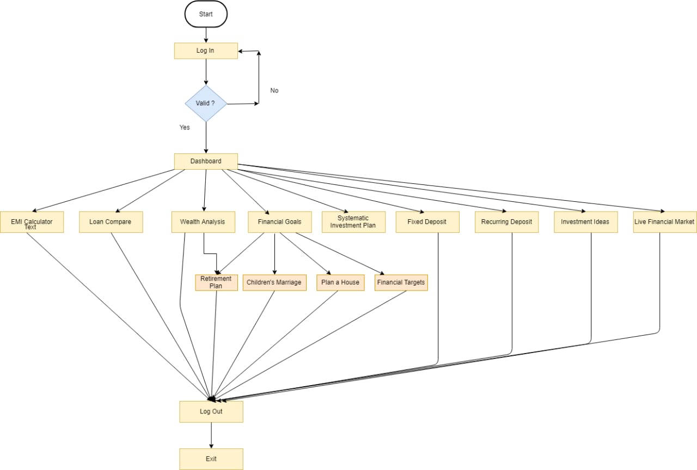

# UML DIAGRAMS:

## Use case diagram:

## 

## Activity diagram: C:\Users\admin\Downloads\Untitled Diagram (1).PNG

## Class diagram:



# List of modules/reports:

## System requirement specification:

* The user must be able to calculate the EMI(Equated monthly installments).
* The user must be able to compare various loans.
* The user must be able to analyze/ manage his/her wealth.
* The user must be able to set the financial goal and plan the investment accordingly.
* The financial goals must include:
  + retirement plan .
  + children’s marriage.
  + plan a house.
  + financial target.
* The user must be able to calculate the SIP(Systematic investment Planning)
* The user must be able to calculate the amount of Fixed deposit.
* The user must be able to calculate the amount of Recurring deposit.
* The user must be able to view the finance website for better investment ideas.
* The user must be able to view the live financial market.
* There must be proper visualized graphs regarding the total amount invested or received.

## Functional requirements (Role and description of entities):

#### EMI calculator:

Description:

* + - Equated Monthly Installment :
      * An agreement is basically signed between the lender and the borrower. The lender provides a specific amount of money to the borrower with the intent that it would be re-paid back with interest on it as the monthly installment by the borrower in a predetermined time of the borrower.
      * In other words, It is basically the equally divided monthly installment that outgoes which is to be paid in a stipulated time frame in order to clear off the debt/outstanding loan.
      * The EMI calculator makes it much more efficient, easier as well as convenient to get to know regarding the loan to be paid through an EMI calculator. It is an easiest way to determine the payout as well as to balance the budget simultaneously.
      * Since, loans have become a daily part of everyone’s life in order to achieve the future goals.
      * It signifies to back the money by the borrower to the lender for the loan repayment of loan or basically the monthly loan EMI payouts.
      * There are certain fields to be filled for calculating the EMI as a result directly:

|  |  |
| --- | --- |
| Fields | About |
| Amount: | This is the principal amount or the loan amount. The amount of money that is borrowed as loan. EMI/monthly installments shouldn’t be more than 40% of your income. |
| Rate of interest:(monthly interest). | The rate or interest signifies the return percent of the loan or the rate of interest levied on the loan amount. |
| Tenure:(in months) | This is the tenure (time-span) in which the loan that is to be re-paid to the lender in order to pay back the outstanding loan. The general range or tenure must be around 1-5 years. |

* + - * + It displays the following features:

|  |  |
| --- | --- |
| Fields | About |
| EMI(monthly payment): | The payment to be done on monthly basis. |
| Total interest payable: | The amount of interest amount that is levied on the loan amount |
| Total payment: | This includes the principal(loan amount) + interest both. |

* + - * The number of EMI is equal to the number of years that are included in the loan repayment tenure.
      * EMI’s are preferred:
        + As they imply less financial pressure on the borrower by paying the amount in bits over a stipulated tenure of loan repayment by the borrower instead of paying it in lump sum i.e. all at once.
        + It helps to afford expensive things such as car, home etc. whatever the financial condition be.
        + It helps notify and provide the flexibility with the amount of money that is actually needed for paying off monthly and the duration based upon your income and financial stability.
        + The EMI contributes to the loan and accrued interest on it.
        + In initial stages, the major component of repayment slightly drifts towards the interest rate which is also termed as the front loading but in later stages it slightly drifts towards the principal amount i.e. the major component of the loan tenure moves towards the repayment of principal amount.
        + The EMI is directly proportional to the principal amount and the interest rate. This means that, if the interest rate and the principal amount increases then the total EMI on the loan also increases. While on the other hand, the EMI is inversely proportional to the loan tenure. howsoever the interest rate is paid if high, the EMI is less paid if the tenure duration is long.
        + Benefits:

Easy access:

It can be accessed anywhere and anytime through the calculator via the financial planner app, without the need for going through the complex mathematical calculations or surfing a banking application.

Accurate results:

This calculator provides the accurate results in the blink of an eye since calculating It manually may lead to enormous errors and in fact comparing the interest rates of different banks may even confuse more.

Aids the financial planning process:

By using this EMI calculator you can actually get an overview of how much is the amount t be paid monthly in order to repay the amount back and it tells you how much of loan you can actually take so that it doesn’t overpower your monthly pay.

You can use the EMI calculator for every kind of loan:

Whether it be a home loan, car loan it can be used to calculate EMI for such loans as well since the parameter remain the same for all. so an EMI calculator can be used to calculate the loan of any type but there maybe instances in which we need a specific loan calculator for calculating i.e. a specific EMI calculator is suitable for a particular type of loan.

* + - * Click on “calculate” in order to compute the EMI.
      * Click on “reset” in order clear all the details filled previously.

#### Loan compare:

Description:

* + - The loan compare module helps you to compare the different loans based on the interest charged by various banking institutions depending upon the tenure and the loan amount borrowed.
    - Here, you can compare 2 loans simultaneously by filling in the compulsory details:

|  |  |
| --- | --- |
|  |  |
| Loan amount: | The amount of loan borrowed from the lender i.e. the principal amount. |
| Tenure: | The duration for the re-payment of loan . |
| Rate of interest: | The interest rate levied on the loan amount that is charged by banks. |

* + - It displays the following (of 2 loans together):

|  |  |
| --- | --- |
| fields | About |
| The EMI (monthly payment): | The monthly amount that is to be re-pay in order to clear off the debt. |
| Total interest: | The total interest amount on the amount deposited. |
| The total payment(principal + interest amount) | The overall payment that is done after the tenure ends with the loan amount along with the rate of interest on it. |

* + - Click on “compare” in order to compute and compare the emi of 2 loans simultaneously.
    - Click on “reset” in order clear all the details filled previously.

### *****Wealth analysis:*****

Description:

* **This module basically tells about your savings and expenses along with the cash you withhold.it also tells you how much you can save from that cash you actually have.**
* **It also tells you how much money in total is invested in how many accounts say for instance: FD(fixed deposit),RD(recurring deposit) where it tells how much money in total have you invested and how much amount is the wealth gain along with the interest on it.**
* **The following details shall be filled:**

|  |  |
| --- | --- |
| **fields** | **About** |
| **Salary** | **The amount of salary/income of an individual.** |
| **Expenses** | **The amount you spend on various things.** |
| **For FD (fixed deposit) and RD(recurring deposit):**  **Tenure:**  **Deposit:**  **Returns(%):** | **The particular time duration after which the amount will get matured.**  **The particular amount of money that is deposited in total.**  **The interest rate that is levied on that amount which is deposited.** |

* + **The following details are displayed:**

|  |  |
| --- | --- |
|  |  |
| **Cash** | **The amount you have currently(i.e salary excluding the expenses).** |
| **Savings:** | **It is the 10% of your total cash in whole.** |
| **Total cash:** | **It is the total cash amount you actually have after excluding the savings.** |
| **For FD(fixed deposit) and RD(recurring deposit):**  **invested amount:**  **Total interest:**  **Returns:** | **It displays the total amount invested in both.**  **It displays the total interest amount.**  **The total gain(principal + interest amount) on it.** |
| **Your total wealth** | **The total wealth after considering the amount invested in FD and RD.** |
| **Total you own:** | **It displays the total amount you actually own currently.** |

## Financial goals:

**Retirement calculator:**

Description:

* + - **It is basically the amount of wealth required before the retirement and the amount of monthly savings required for securing yourself financially.**
* **There are certain fields that are need to be filled in:**

|  |  |
| --- | --- |
| **Fields** | **About** |
| **Current age:** | **The present age.** |
|  |  |
| **Retirement age:** | **The age at which you’ll be retiring** |
| **Monthly expenses after retirement:** | **The amount of money that you wish to have as monthly expenses after you get retired in order to secure yourself.** |

**Click on the “GO” button to proceed further.**

* + - * + **Details that are displayed:**
        + **In the difference of years between the current age and retirement age , to make your desired lifestyle at least for 30 years after retirement you will be requiring at least:**

**The amount is displayed that is required in order to make that much amount of monthly expenses later as per your retirement plan i.e the total wealth you must withhold in order to fulfil the desired amount needed after retirement.**

* + - * + **Click on “next” button in order to proceed further.**
  + **The following detail is displayed:**

|  |  |
| --- | --- |
| **fields** | **About** |
| **Monthly investment should be to achieve the desired amount:** | **It refers to the monthly deposit that is needed in order to cover up the retirement money or to get the desired amount of monthly expenses after retirement.** |
| **A graph is also displayed depicting:** | **The debt.**  **The equity.** |

* + - **Benefits:**
      * **The post-retirement is the golden period of life. It is the phase of life where an individual pursues what he/she exactly loves to do by turning the hobbies into passion.so there must be proper, extensible and a pre-plan in a structured manner with years of persistence is required.**
      * **Improved life expectancy:**

**There is an increase in the need of the healthcare and medical facilities with the increase in the life expectancy and so there must be enough wealth in order to facilitate yourself after retirement.**

**Individualism:**

**Whether you have planned for the finances for yourself and for the children as well throughout your life and whether they support you enough or not , keeping this in mind its not preferred to be financially dependent on them even after you retire. So this problem can be curbed by simply creating or rather setting a structured retirement plans.**

**Contribution to the family:**

**Sometimes, you may desire to support your children in certain life events so these retirement funds also assist you along with the financial independence.**

**Insufficient employee funded pension:**

**At certain times, the pension that is provided by the government isn’t sufficient to assist your needs and requirements and the kind of lifestyle you dread to live. So its better you have a protective cushion just to live the life you actually desire under any situation.**

**Pursuit of interest:**

**It is within the realm of possibility that you can actually go on a vacation of you can continue your hobby as a profession when your free from your workplace responsibilities. The retirement planning calculator helps you to achieve those aspirations.**

#### Home –loan calculator:

Description:

* + - Planning plays a crucial part as endeavor in life. Since planning for a home or buying a property requires rigorous and appropriate planning which otherwise it will dent your finances. Since, you are borrowing hefty amounts so you must plan accordingly in order to that you are able to repay it.
    - The EMI regarding your home loan is the home loan EMI calculator. In India its better to calculate the amount that is to be repaid based on the money borrowed for the home loan purpose or rather to get an idea regarding the amount of loan that can be borrowed so that there is no financial crisis over-burdening you.
    - Hence the EMI loan calculators are an easy-to –use calculator that helps you to access the repayment capabilities hand on hand.
    - Step up and step down EMI:
      * The EMI can be categorized as the step down and step up EMI. Where the EMI monthly payment varies according to the increase/decrease in the borrowers salary .
      * In step –up EMI, the monthly payment gradually increases as the salary of borrower increases . Generally, the EMI is low and then it gradually increases at the nearing of the tenure. But this isn’t applicable in case of home loan emi.so it’s a good saving option for the individuals having a financial instability. The change in the EMI is done 2 times a year during the entire tenure.
      * While in step-down EMI the EMI is high at the start but it gradually decreases with the number of payment done hence it is more suitable for those who are having financial stability.
    - Benefits:
      * Saves you precious time:

Using the EMI home loan calculator you can easily compute it without wasting any time. By just filling in the details with reference to your home loan.

Gives you accurate results:

Instead of just manually calculating the EMI of your you can actually compute it using the EMI home loan calculator that will give the accurate results on the spot.

* + - * Helps you better plan your finances:

With the help of this home loan EMI calculator you can actually know your capacity in terms of repayment and the amount of home loan that can actually be borrowed.

* + - * Why take a home loan?

Funding your home:

Buying a home is one of the massive financial goals. so in order to assist the financial plans for providing funds regarding the home loans is quite effortless when the loan amount is repaid in parts i.e. monthly rather than paying the hefty amount from your insufficient saving account.

Building up a credit score:

The credit scores depict the credit worthiness of an individual. The credit scores are accessed by the lenders to decide how much amount of loan can be sanctioned to a particular borrower based upon the repayment capacity. The home loan tenure can be as long as the 20 years (30 years in some cases as well) and so until that duration the credit scores can be increased well.

Capital appreciation:

Since, the property rates have taken a positive run in the past years , its still continuing to maintain this surge for the upcoming years as well. because of the increase in property prices, construction cost as well as the rents substantially for few years, so investing in home loan is actually a more lucrative deal than any other and so in order to shield it from the inflation for a long term. Hence, capital appreciation is the reason for investing in the property.

#### ****Financial target:****

Description:

* + - **It tells how much amount of monthly investment is required and under which schemes in order to achieve the target amount.**
    - **Certain fields must be entered:**

|  |  |
| --- | --- |
| **fields** | **about** |
| **Target:** | **The target amount that is required to achieve.** |
| **In how many years you want to achieve this target?:** | **The tenure(i.e. the stipulated time) required to achieve that target amount.** |

* **Click on ‘ok’ button, it displays the various funds/schemes giving returns:**

**Aditya Birla Sunlife(15%)**

**Reliance Japan Equity(20%)**

**Franklin Infotech(30%)**

* + - * **Click on ‘start invest’ button and displays the monthly investment to be done.**

#### SIP calculator:

Description:

* + - Systematic Investment Planning: For any successful person it is required to invest rightly. So for a prospective investor it gauges with the fruitful earning/ returns over a specific period of time and for a specific amount that is invested(monthly) .
    - The investor may have a fixed goal in mind such as corpus retirement or so , so how much should be the monthly installment in order to provide that required corpus.
    - Benefits:
      * The user may know how much amount need to be paid, specifically monthly in order to get the amount of money that is required over a pre-determined tenure.
      * It eases the strain and helps them getting accurate results in the blink of an eye.
      * It not only helps the people having the financial background but also people with non-financial background.
      * It assists to take proper informed decisions for the mutual fund investors and to calculate the amount of future returns as well.
      * It helps to potentially invest a large amount of money without straining the monthly finances.
      * The following fields are mandatory to be filled:

|  |  |
| --- | --- |
| fields | About |
| Monthly deposit: | The amount that would be deposited monthly. |
| Expected yearly return(%): | The rate of interest on the monthly investment that is expected to return after a stipulated fixed tenure. |
| Period:(min 1 year for wealth creation): | The specified tenure, after which the final amount can be calculated along with the return percent on it. |

Click on the ‘RESET’ button to refresh all the details.

Click on the ‘CALCULATE’ button to get the SIP result.

The following details are displayed:

|  |  |
| --- | --- |
| fields | About |
| Expected amount: | The amount that is expected to be received after the interest on it. |
| Amount invested: | The amount that is deposited on monthly basis. |
| Wealth gain: | The amount of money gained i.e. the profit(interest amount) earned on the maturity amount value. |

A pie chart is also displayed showing 2 legendries- investment(%) and returns(%) respectively.

* + - How SIP is different from Lump Sum?
      * In lump sum ,its required to invest large amount of money all at once which can be at time strenuous to the individuals who are salaried . so a better approach is to invest it monthly in bits for a longer duration in order to get the better returns for future expenses.
      * In case of lump sum investment all the mutual fund units are bought at the same price, so the profit/loss incurred at the time of liquidating the units would be exactly same for all. Whereas, in case of small amount investment, the mutual fund units are bought at separate times and at separate prices, so the profit/loss incurred at the time of liquidating the units differs from one unit with the other.

#### The fixed deposit calculator:

Description:

* + It is a term deposit that is offered by banks or certain non-financial banks as well. the FD’s have higher interest rate than savings account under certain terms and conditions. the invested amount shall be locked for certain time period range between 7 days to 10 years. the interest earned on FDs is paid out at regular intervals or depending on the investors choice. Using the FD calculator you can actually check the interest as well as the maturity amount that the depositor will get after a certain tenure. the maturity amount of the fixed deposit is paid out at the end of tenure.
  + Certain details need to be filled in for calculating the FD:

|  |  |
| --- | --- |
| Fields | about |
| Tenure(Year): | The amount that is deposited shall be locked in for a particular tenure. and you can avail FD for a tenure raging between 7 days to 10 years. different institutions may have different tenure conditions so its preferred to compare the tenure conditions of various institutions and make decision wisely. The important thing to notice here is that based upon the tenure the bank decides the rate that is to be given. The longer the tenure, higher is the FD interest rate. |
| Rate of interest(%): | The interest rates maybe high as savings account depending upon the amount and the tenure. The interest rates may vary from one bank to another. The interest payout mainly is done quarterly, half-yearly, yearly based upon and they vary between various FD schemes.  However the interest rate for the tax saving FD is always made at the beginning of the financial year by the government and is same across all the banks. |
| Total deposit: | The investment in fixed deposit is made only once and the min amount of opening a FD may vary again from institution to other institution.  You can start will as low as 5000 INR and upto 10 crore INR too. |

* + - Benefits:
      * Assure returns:

It yields a secure investment and assures a secure return over a period of time.

* + - * Inculcates saving habit:

Since the amount deposited is locked in for a fixed- tenure so it helps to develop savings habit.

* + - * Early withdrawal:

It also provides with the flexibility of withdrawing earlier than the tenure with a nominal penalty charge on it.

* + - * Flexible tenure options:

You can choose the tenure as much as you want in order to lock in the amount during that particular period.it may be either 1 week or 10 years.

* + - * Interest payable:

Interest can be paid out on maturity annually or on monthly basis.

* + - * Better returns than savings account:

In a savings account you can get only 6% return while on fd you can earn an interest of at least 7% based on various institutions.

* + - * Click on “calculate” in order to compute the fixed deposit.
      * Click on “reset” in order clear all the details filled previously.
    - The following details are displayed:

|  |  |
| --- | --- |
| fields | About |
| Amount invested: | The total amount that is invested at once and that is locked in for a fixed time duration. |
| return: | the interest amount that is given by banks that is levied on the deposit amount. |
| Wealth gain: | The total amount that is matured after a fixed time duration i.e. the deposit amount + interest. |

* FD calculator by different banks/institutions:

|  |  |  |  |
| --- | --- | --- | --- |
| Bank/Institution | Investment amount | tenure | Interest rate |
| SBI | Minimum – ₹ 1,000 Maximum – No Limit | Minimum – 7 days  Maximum – 10 years | Minimum – 5.75%  Maximum – 6.75% |
| HDFC | Minimum – ₹ 1,000  Maximum – No Limit | Minimum – 7 days  Maximum – 10 years | Minimum – 3.50%  Maximum – 7.25% |
| ICICI | Minimum – ₹ 1,000  Maximum – No Limit | Minimum – 7 days  Maximum – 10 years | Minimum – 4.00%  Maximum – 7.25% |
| PUNJAB NATIONAL BANK | Minimum – ₹ 100  Maximum – 10 crore | Minimum – 7 days  Maximum – 10 years | Minimum – 5.70%  Maximum – 6.35% |
| AXIS BANK | Minimum – ₹ 5,000  Maximum – No Limit | Minimum – 7 days  Maximum – 10 years | Minimum – 3.50%  Maximum – 7.25% |
| BANK OF BARODA | Minimum – ₹ 1,000  Maximum – No Limit | Minimum – 7 days  Maximum – 10 years | Minimum – 4.00%  Maximum – 7.25% |

#### Recurring deposit:

Description:

* + - Recurring deposit is a savings option which allows to make in order to accommodate the future needs. People having regular income can make financial provisions by investing some amount of income over a pre-determined period and earn interests on those investments as high as fixed deposits. when the deposit finally matures including the principal as well as the interest on it that is paid back to you. Moreover, the interest rates are fixed until the amount matures while it may fluctuate unlike many other products.
    - With the help of recurring deposit calculator you can easily get to know about the potential earnings as well as , no matter at what interest rate it is being offered to you.
    - Features for RD:
      * It is effective since it inculcates the saving habit among the individuals.
      * You can deposit as min as starting for 10 Rs and it go to a maximum of 10 crore depending on various institutions and its norms.
      * The RD interest rate is almost equal to the RD interest rate which is slightly higher than the savings account for most of the banks.
      * Additionally, there is a flexibility in choosing the tenure period which must be at least 6 years and may be upto 10 years if required.
      * FD also offers an additional benefit of taking loans collaterally against that deposit.
      * The deposits can be made/funded directly through your savings account or through you current account without as per the instructions given by the bank.
      * The RD calculator helps to calculate the maturity amount (principal+ interest returns) of that deposit as per various norms of financial institutions.
      * Following details are mandatory to be filled:

|  |  |
| --- | --- |
| fields | about |
| Rate of interest(%): | The rate of interest are high that are provided by banks and which may vary from 3.5% to 8.5% depending on the deposit tenure, the amount and the bank. For shorter tenures, the interest rates are similar to that savings account but if the tenure is long then the interest rates are high.  Banks also provide additional interest rates for senior citizens as well.  Hence, one must check and compare the different interest rates that the different banks provide in order to earn higher returns on investment. |
| Tenure(year): | Once, you invest you shall choose the RD with higher rates of interest for a shorter duration. For instance, if a bank provides a rate of interest 7.4% for a period of 1 year and 7.1%p.a. for 14months, so the investor shall choose the RD scheme of the previously mentioned. |
| Monthly deposit amount: | The amount that is to be invested monthly in order to see the maturity amount after the tenure ends. |

* Click on “calculate” in order to compute the recurring deposit result.
* Click on “reset” in order clear all the details filled previously.
  + - * The following details are displayed:

|  |  |
| --- | --- |
| fields | About |
| Amount invested: | The total amount that is deposited on monthly basis is displayed here, for a particular tenure. |
| Returns: | The interest amount levied on the invested amount. |
| Wealth gain: | The total amount that is matured and after a stipulated period of time along with the interest on it. |

* + - Recurring deposit for the senior citizens:
      * The recurring deposit schemes for the senior citizens is a bit more higher than the regular citizens. There is a minimum tenure and the loan amount as per norms of various banking institutions. While the interest rates offered to the senior citizens is 0.5% more than that offered to the regular citizens.

|  |  |  |
| --- | --- | --- |
| **Recurring Deposit with Bank** | **Interest for Regular Individuals** | **Interest for Senior Citizens** |
| SBI Bank | 5.75% to 6.75% p.a. | 6.25% to 7.25% p.a. |
| Kotak Mahindra Bank | 6.25% to 7.20% p.a. | 6.75% to 7.70% p.a. |
| IDFC Bank | 6.75% to 7.25% p.a. | 6.75% to 7.25% p.a. |
| Axis Bank | 3.5% to 7.4% p.a. | 3.5% to 8.05% p.a. |
| ICICI Bank | 6% to 6.75% p.a. | 6.50% to 7.25% p.a. |

#### ****Investment ideas:****

Description:

* + **It helps the user to browse through the website i.e.** [www.businesstoday.com](http://www.businesstoday.com) **for better information gathering.**
  + **The following is displayed:**
    - [www.businesstoday.com](http://www.businesstoday.com) **website:**
      * **The investment ideas module re-directs it to the** [www.businesstoday.com](http://www.businesstoday.com) **website.**

#### ****Live financial market**:**

Description:

* **It helps the user to access the live financial market i.e. CNBC for knowing regarding the current market trends.**
* **The following is displayed:**
  + **CNBC live market:**
    - **the Live financial market module re-directs it to the CNBC live financial market.**

## ****Non-functional requirement:****

* + **Quick responsive:**
    - **The system shall be quick responsive for users effortless accessibility.**
  + Reliability Requirement and Efficiency Requirement:
    - The system must give accurate result whenever the user provides the input details as per specified and in a swift pace.
  + **Better user-interface layout:**
    - **The user-interface must be simple and not too complicated for the system to have a good appeal and feel and as well with proper components such as the color pallet, the design, the font type, font size etc. as per the theme or topic chosen.**
  + **24*7 availability and accessibility:**
    - **It must be 24*7 available for the users to access anytime and from anywhere in an instant.**
  + Usability Requirnment:
    - Creates a user-friendly environment so that it can be **Effectively ,efficiently and used by the users in a flexible manner.**

# User interface modelling:

#### Splash screen:

­­­

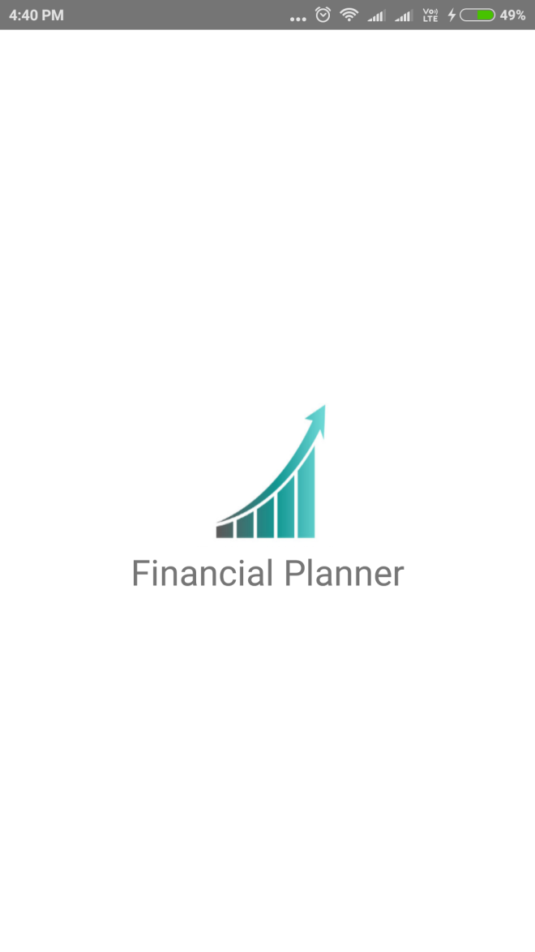

#### Login screen:

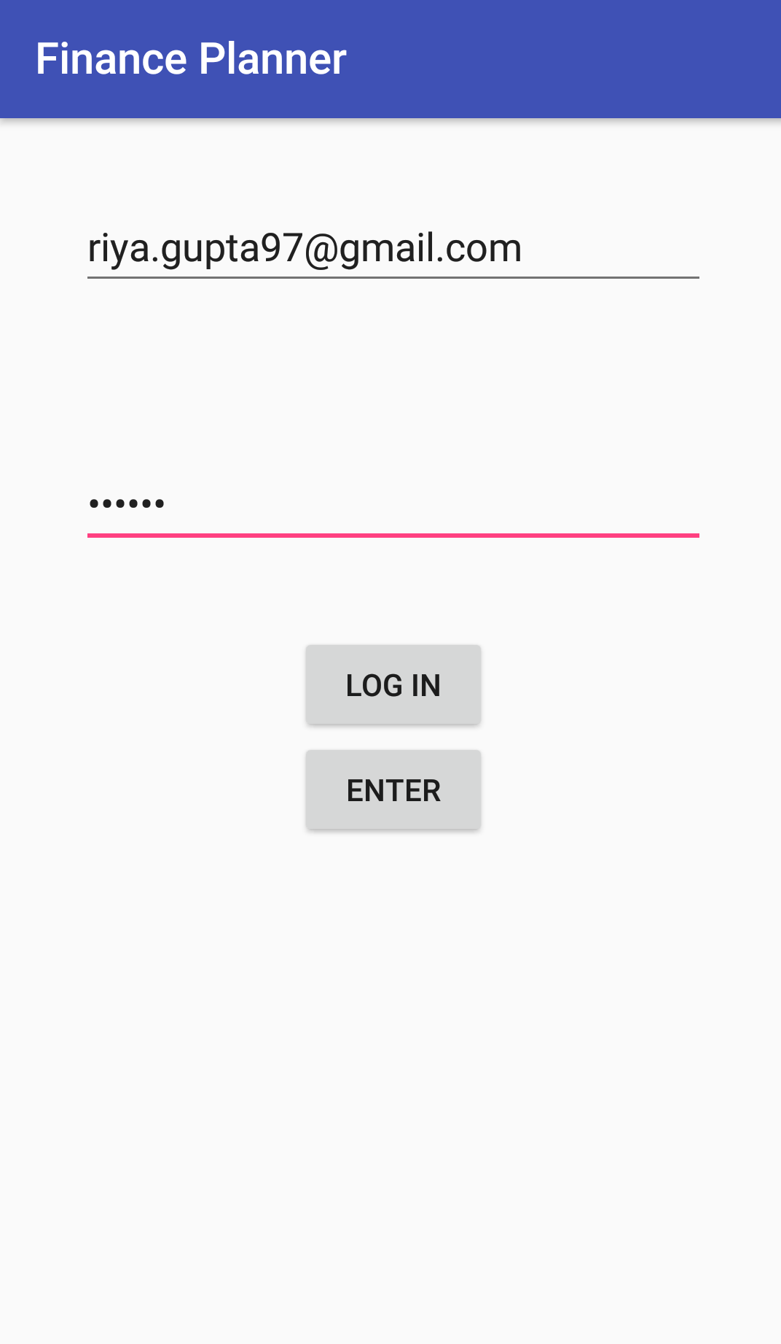

#### Login specifications:

|  |  |  |
| --- | --- | --- |
| Data/UI elements | Data considerations | Behavior considerations |
| Username | Text entry field | Mandatory field.  Displays the username as entered as per the specifications. |
| Password | Text entry field | Mandatory field.  Displays the password(in encrypted format)as entered as per the specifications. |
| Login | Button | On users click, when the password matches the one in the database, this screen redirects it to the dashboard screen. |
| Enter | Button | (for temporary purpose) it will directly redirect to the dashboard screen. |

#### Dashboard-1:

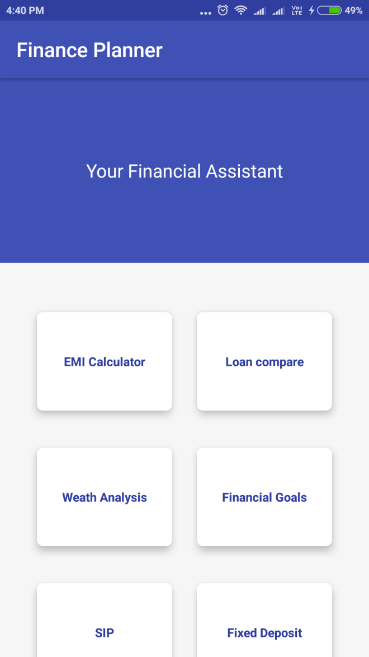

#### Dashboard-2:

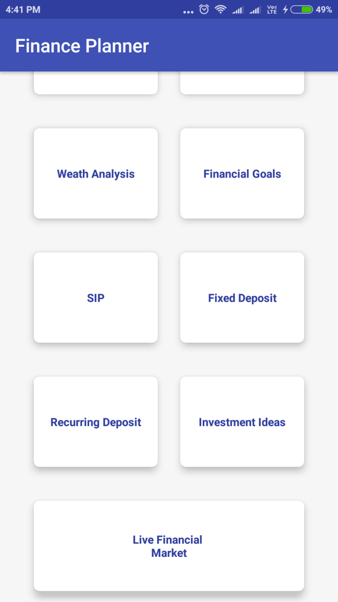

#### Dashboard Specifications:

|  |  |  |
| --- | --- | --- |
| **Data/UI elements** | **Data considerations** | **Behavior considerations** |
| Emi calculator | Cardview | On users click displays the EMI calculator screen. |
| Loan compare | Cardview | On users click, a loan compare page open that compares 2 loans. |
| Wealth analysis | Cardview | On users click, it displays the analysis of wealth stored in various modules such as RD,FD. |
| Financial goals | Cardview | On users click, it displays a page again with 4 more modules ie. The retirement plan, childrens marriage, plan a house and financial target. |
| SIP | Cardview | On users click, it displays a Systematic investment planning page. |
| Fixed deposit | Cardview | On users click, it displays a Fixed deposit page. |
| Recurring deposit | Cardview | On users click, it displays a Recurring deposit page. |
| Investment ideas | CardView | On users click, it re-directs to a page opening a browser inside the app itself and also re-directs [www.businesstoday.com](http://www.businesstoday.com) |
| Live financial market | CardView | On users click, it re-directs to a page opening a browser inside the app itself and also re-directs it to the CNBC tv channel. |

#### EMI calculator screen:

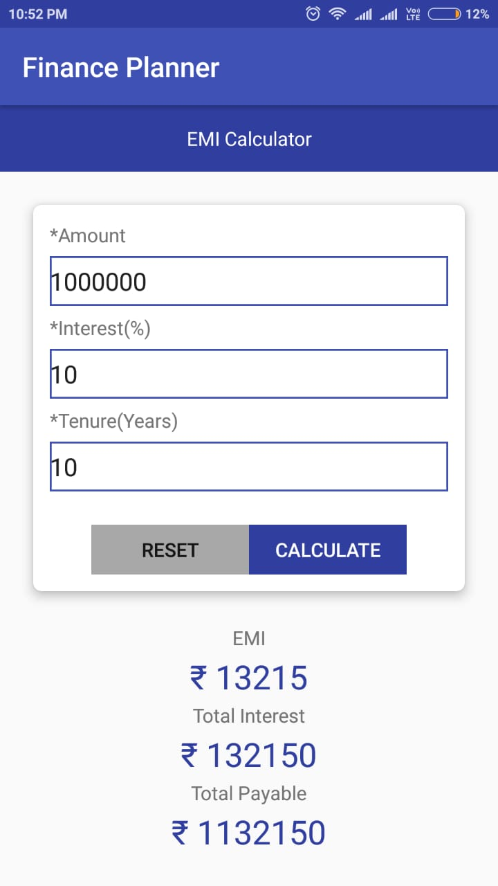

#### EMI Specification

|  |  |  |
| --- | --- | --- |
| **Data/UI element** | **Data considerations** | **Behavior considerations** |
| Amount | Text entry field | Mandatory field.  Displays the amount as entered. |
| Interest | Text entry field | Mandatory field  Displays the interest as entered |
| Tenure | Text entry field | Mandatory field  Displays the tenure as entered. |
| Reset | Button | On users click, it refreshes the all the details previously filled. |
| Calculate | Button | On users click, it calculates the EMI and gives the result. |
| EMI | Textview | It displays the EMI result |
| Total interest | Textview | It displays the interest amount that is levied on the loan amount. |
| Total payable | Textview | It displays the amount deposited(principal amount)+interest on it. |

#### Loan compare-1:

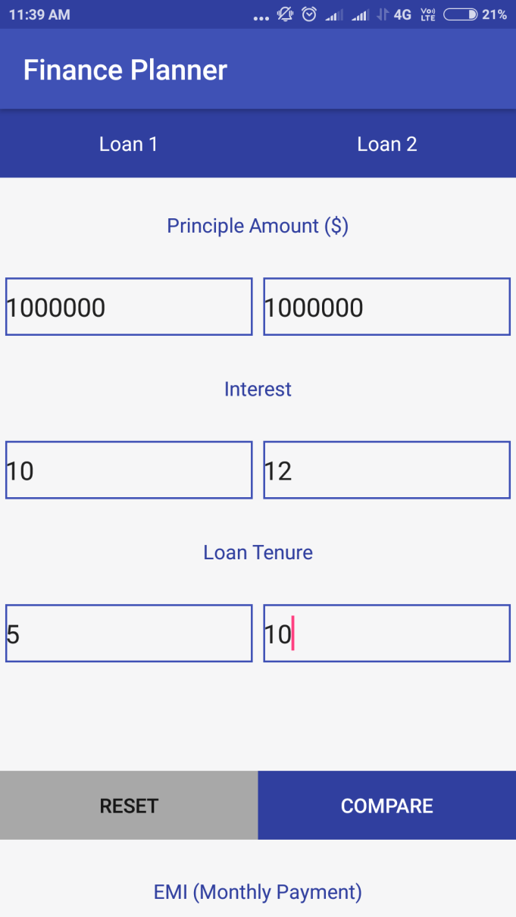

#### Loan compare 2:

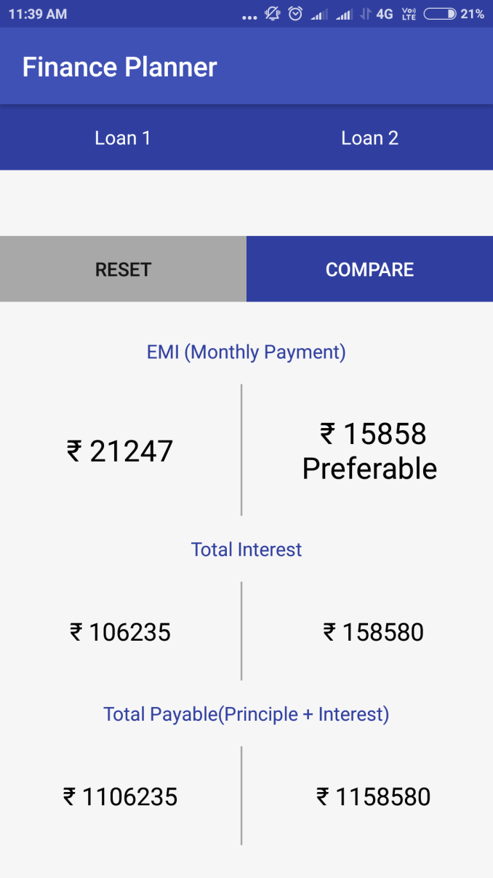

#### Loan Compare Specifications:

|  |  |  |
| --- | --- | --- |
| **Data/UI element** | **Data considerations** | **Behavior considerations** |
| Principal Amount | Text entry field | Mandatory field.  Displays the amount as entered. |
| Interest(%) | Text entry field | Mandatory field  Displays the interest(monthly) as entered |
| Loan Tenure(year) | Text entry field | Mandatory field  Displays the tenure(year) as entered. |
| Reset | Button | On users click, it refreshes the all the details previously filled. |
| Calculate | Button | On users click it calculates the EMI and gives the result. |
| EMI(monthly payment) | Textview | It displays the EMI result |
| Total interest | Textview | It displays the interest amount that is levied on the loan amount. |
| Total payable | Textview | It displays the amount deposited(principal amount)+interest on it. |

#### Wealth analysis-1:

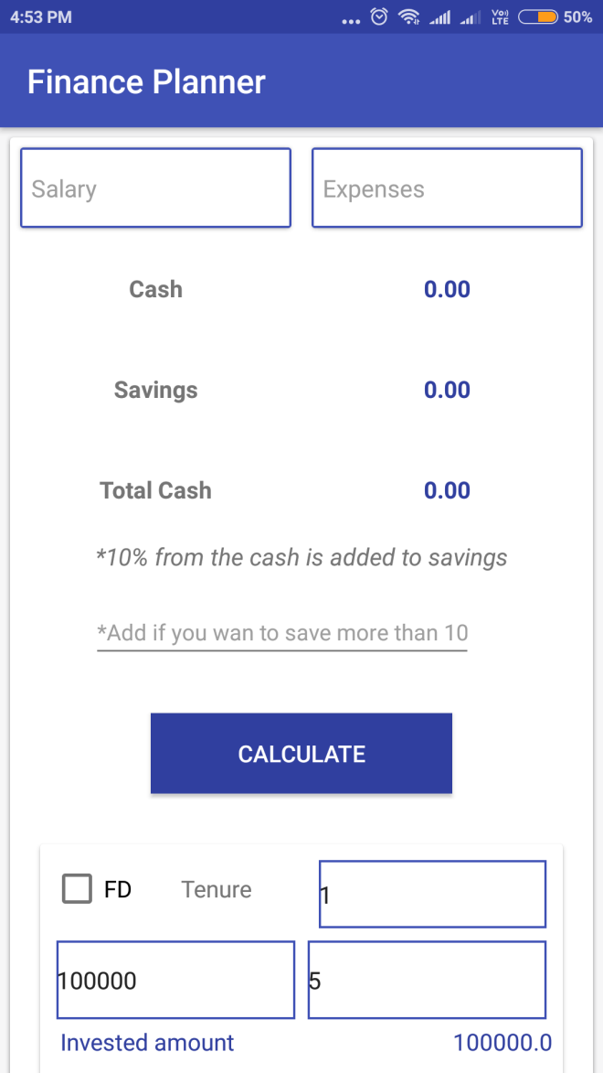

#### Wealth analysis-2:

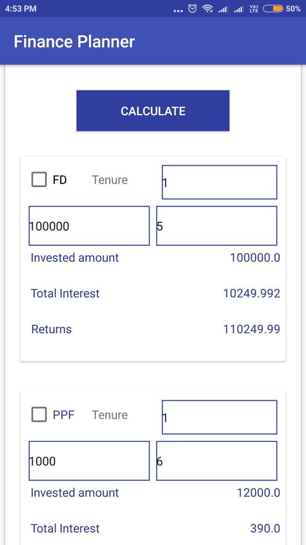

#### Wealth analysis-3:

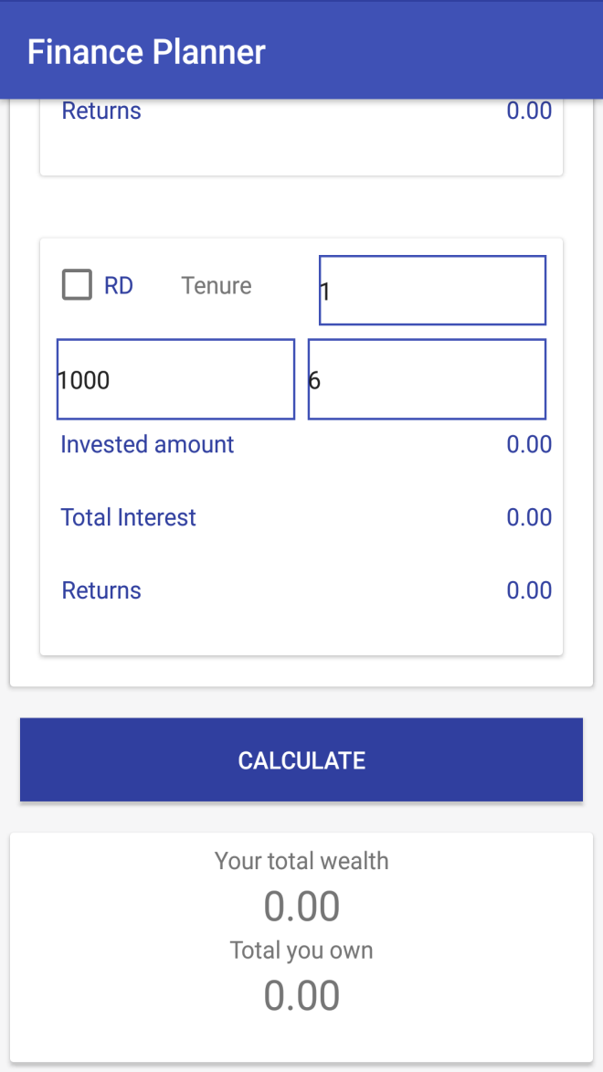

#### Wealth Analysis Specifications

|  |  |  |
| --- | --- | --- |
| Data/ui elements | Data considerations | Behavior considerations |
| Salary | Text entry field | Mandatory field. It displays the salary of the user as entered. |
| Expenses | Text entry field | Mandatory field. It displays the expenses incurred by the user as entered. |
| Cash | Textview | It displays the amount of cash left (i.e. the salary minus the expenses) |
| Savings | Textview | It is the 10% amount from the cash left with the user. |
| Total cash | Textview | It displays the total cash withhold (i.e. 10% from the cash is added to savings) |
| Calculate | Button | On users click, it displays the above details. |
| Fixed deposit(FD) | Check box | When the user clicks on the checkbox, it displays the tenure, the amount invested and rate of interest as entered. |
| Invested amount | Textview | It displays the total amount invested for a particular duration. |
| Total interest | Textview | It displays the interest amount (levied on the amount deposited) |
| Returns | Textview | It displays the total amount that is received (i.e. principal amount+ interest) |
| Recurring deposit(RD) | Checkbox | When the user clicks on the checkbox, it displays the tenure, the amount invested and rate of interest as entered. |
| Invested amount | Textview | It displays the total amount invested for a particular duration. |
| Total interest | Textview | It displays the interest amount (levied on the amount deposited) |
| Returns | Textview | It displays the total amount that is received (i.e. principal amount+ interest). |
| Calculate | Button | On users click, it displays the your total current wealth in hand (invested amount in total)and the total amount you own(the total returns). |

#### Financial goals:

#### :

#### 

#### Retirement plan-1:

## 

## 

#### Retirement plan-2:

#### 

#### Retirement plan-3:

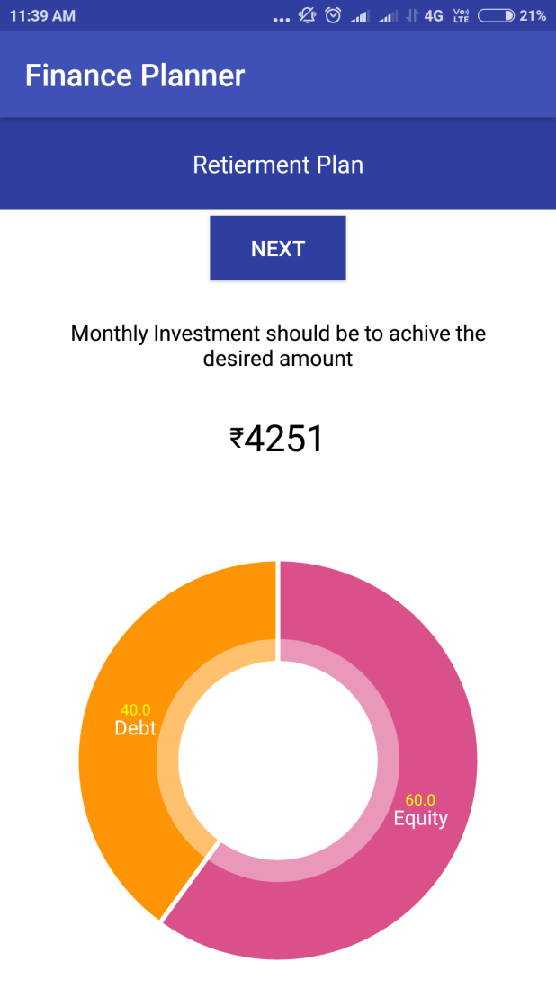

#### Retirement Specifications:

|  |  |  |
| --- | --- | --- |
| **Data/UI element** | **Data considerations** | **Behavior considerations** |
| Current age | Text entry field | Mandatory field.it displays the current age of the user as entered. |
| Retirement age | Text entry field | Mandatory field.it displays the retirement age of the user as entered. |
| Monthly expenses after retirement | Text entry field | Mandatory field.it displays the monthly expenses that are actually needed or rather desired too have after retirement as entered. |
| Go | Button | On users click, it proceeds further to calculate how much money is actually required in ordered to get that much amount of desired monthly expenses after retirement. |
| Next | Button | On users click, it displays the result based on the monthly investment that is required to achieve that much amount. and also displays a pie chart, showing two legnedaries:1.equity 2.debt |

#### Home plan-1:

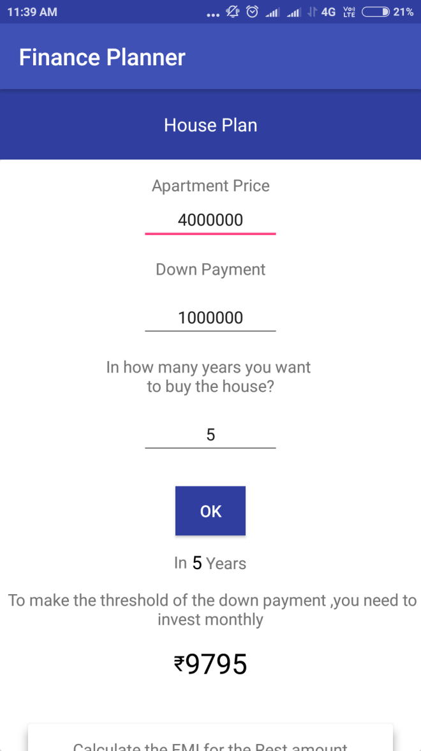

#### Home plan-2:

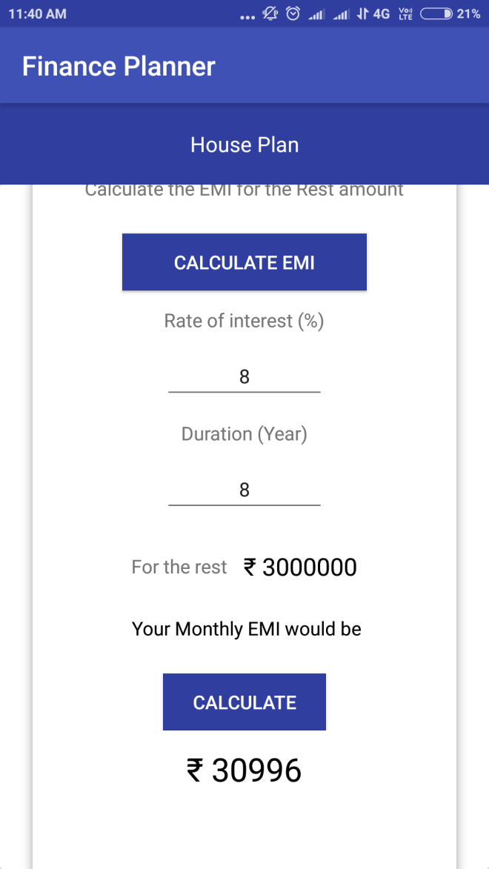

#### Home Plan Specifications:

|  |  |  |
| --- | --- | --- |
| **Data/UI elements** | **Data considerations** | **Behavior considerations** |
| Apartment price | Text entry field | Mandatory field. It displays the price of the apartment as entered. |
| Down payment | Text entry field | Mandatory field.it displays the amount that is to be paid in advance. |
| In how many years you want to buy the house? | Text entry field | Mandatory field.it displays the tenure as entered. |
| Ok | Button | On users click, it displays that in how many years(as per the tenure entered) ,how much monthly investment is required to make the threshold of the down payment. |
| Calculate EMI | Button | On users click, it displays the monthly deposit that is need to make in order to pay back the apartment price(apart from the down payment) |
| Rate of interest (%) | Text entry field | Mandatory field.it displays the rate of interest i.e. levied on the amount. |
| Duration(year) | Text entry field | It displays the tenure as entered. |
| For the rest | Text entry field | It displays the amount EMI required to pay the rest amount. |
| Calculate | Button | On users click, it displays the EMI result based on the above details filled. |

#### Financial target-1:

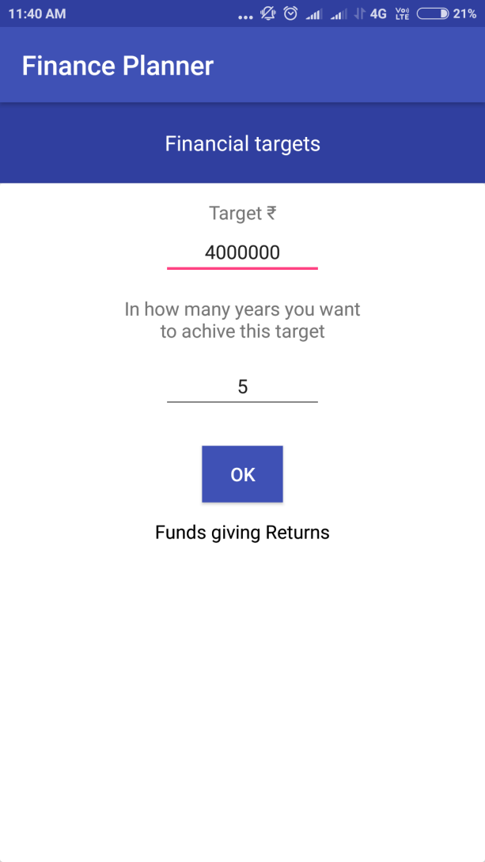

#### Financial target-2:

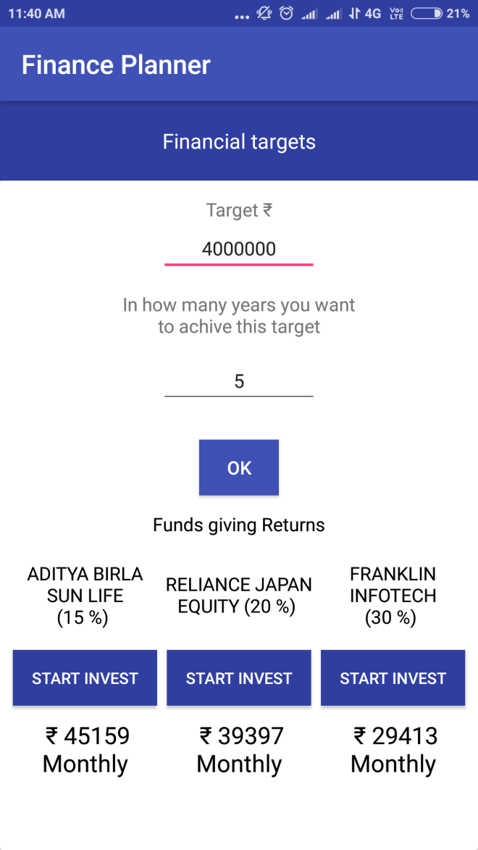

#### Financial target-3:

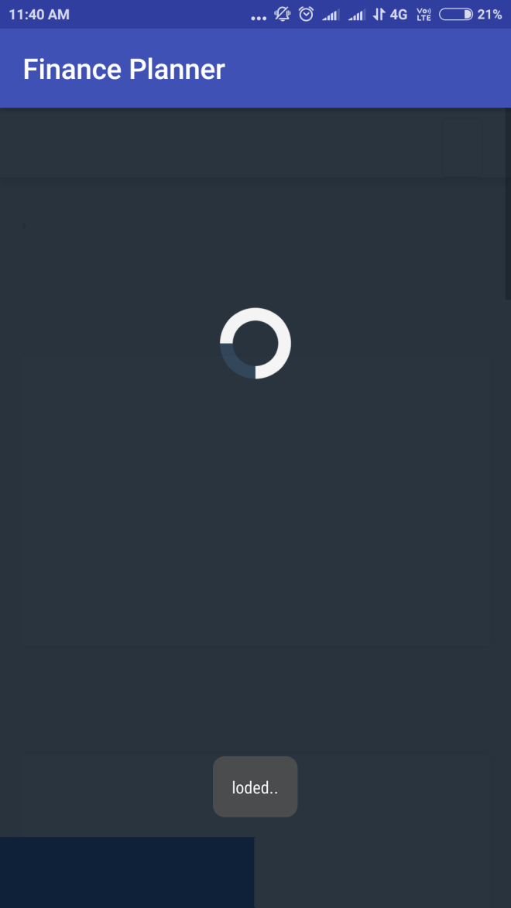

#### Financial target-4:

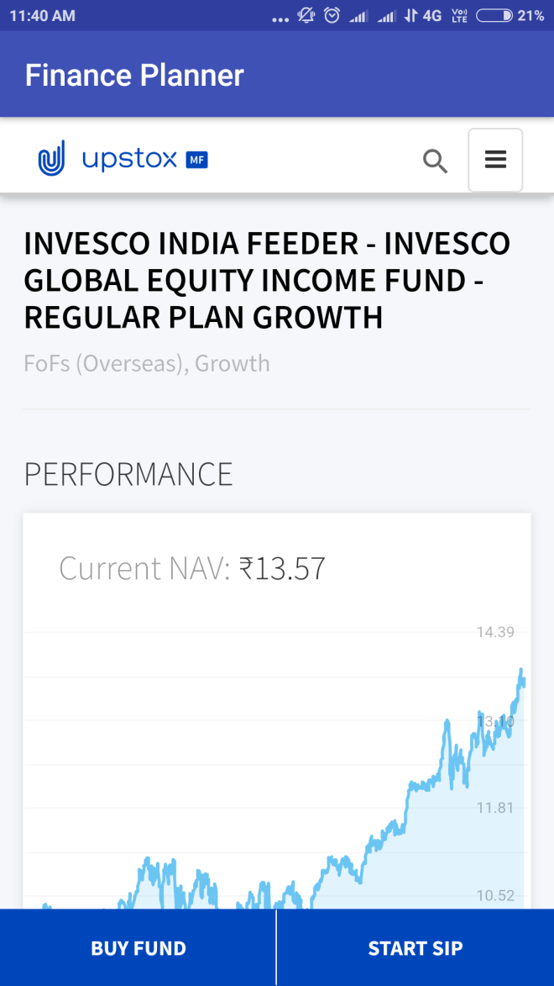

#### Financial Target Specifications:

|  |  |  |
| --- | --- | --- |
| **Data/ui elements** | **Data considerations** | **Behavior considerations** |
| Target | Text entry field | Mandatory field.it displays the amount that is needed in future. |
| In how many years would you want to achieve the target? | Text entry field | Mandatory field.it displays the tenure period that is required to get that much amount of money as specified. |
| Ok | Button | On users click, various schemes are displayed indicating various rate of interests provided by them. |
| Start invest | Button | On users click, it displays how much amount id needed to invest monthly and it redirects to the website browser. |
| Buy fund | Button | on users click it helps to buy the fund. |
| Start SIP | Button | On users click it redirects the page to buy the SIP. |

#### Systematic investment planning-1:

#### 

#### 

#### Systematic investment planning-2:

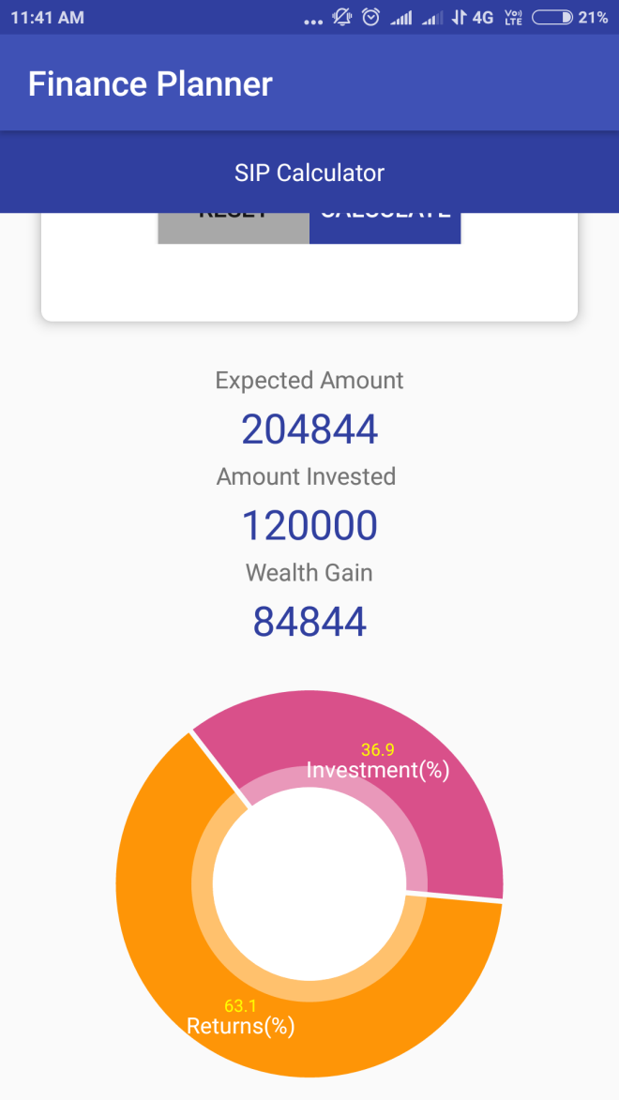

#### Systematic investment planning Specifications:

|  |  |  |
| --- | --- | --- |
| **Data/UI element** | **Data considerations** | **Behavior considerations** |
| Monthly deposit | Text entry field | Mandatory field. Displays the amount that is deposited monthly as entered. |
| Expected yearly return (%) | Text entry field | Mandatory field. Displays the rate of interest s entered. |
| Period (Min 1 year for wealth creation) | Text entry field | Mandatory field. Displays the tenure and must be at least 1 year duration as entered. |
| Reset | Button | On users click, it refreshes the all the details previously filled. |
| Calculate | Button | On users click ,it calculates the  Systematic investment amount and gives the result. |
| Expected amount | Textview | It displays the amount that will be received after a particular duration. |
| Amount invested | Textview | It displays the total amount actually invested. |
| Wealth gain | Textview | It displays the amount of profit gained after interest on accrued in the amount deposited. |
| Calculate | Textview | On users click ,it calculates the  Systematic investment amount and gives the result. |
| Pie chart | Pie chart | It displays 2 legendaries- investment(%) and returns(%). |

#### Fixed deposit-1:

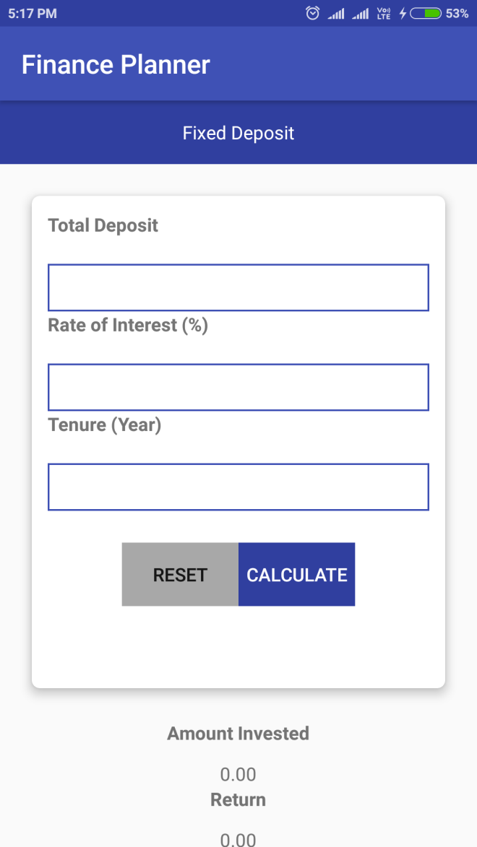

#### Fixed deposit-2:

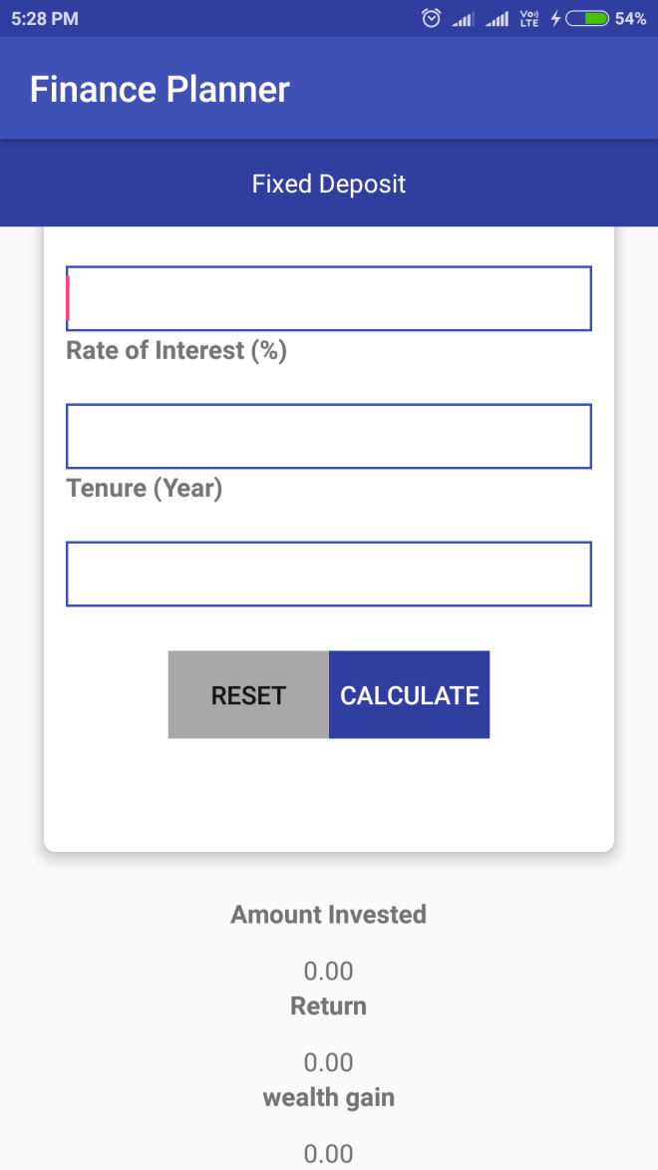

#### Fixed deposit Specifications:

|  |  |  |
| --- | --- | --- |
| **Data/UI element** | **Data considerations** | **Behavior considerations** |
| Total deposit. | Text entry field | Mandatory field. Displays the amount that is deposited monthly as entered. |
| Rate of interest (%) | Text entry field | Mandatory field. Displays the rate of interest s entered. |
| Tenure(year) | Text entry field | Mandatory field. Displays the tenure in years format as entered. |
| Reset | Button | On users click, it refreshes the all the details previously filled. |
| Calculate | Button | On users click it calculates the Fixed deposit and gives the result. |
| Amount invested | Textview | It displays the total amount actually invested. |
| Return | Textview | It displays the total interest amount on that total deposit. |
| Wealth gain | Textview | It displays the amount of profit gained after  interest accrued on the amount deposited. |

#### Recurring deposit-1:

#### 

#### Recurring deposit-2:

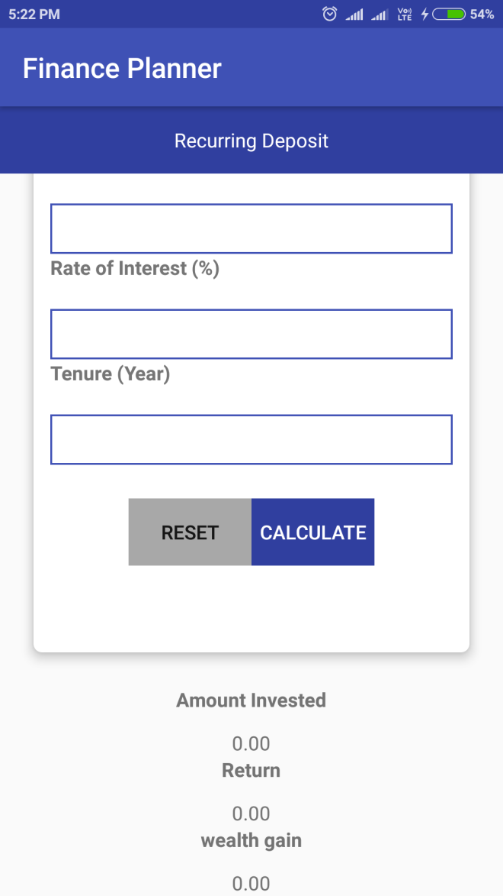

#### Recurring Deposit Specifications:

|  |  |  |
| --- | --- | --- |
| **Data/UI element** | **Data considerations** | **Behavior considerations** |
| Monthly deposit amount | Text entry field | Mandatory field. Displays the amount that is deposited monthly as entered. |
| Rate of interest(%) | Text entry field | Mandatory field. Displays the rate of interest s entered. |
| Tenure(year) | Text entry field | Mandatory field. Displays the tenure in years format as entered. |
| Reset | Button | On users click, it refreshes the all the details previously filled. |
| Calculate | Button | On users click, it calculates the Recurring  deposit and gives the result. |
| Amount invested | Textview | It displays the total amount actually invested. |
| Return | Textview | It displays the interest amount on the amount invested. |
| Wealth gain | Textview | It displays the amount of profit gained after interest accrued on the amount deposited. |

#### Investment ideas-1:

#### 

#### Investment Ideas-2:

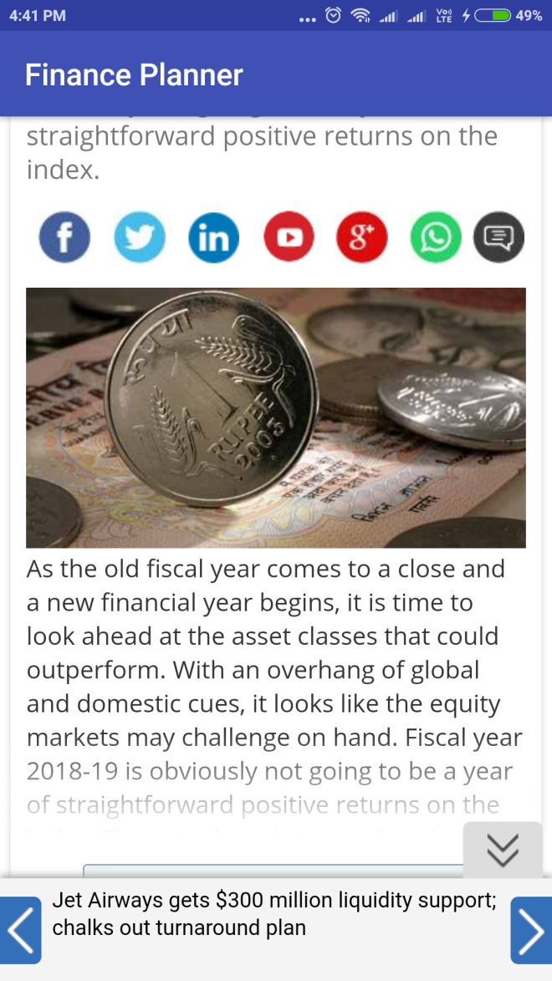

#### Investment Ideas Specifications:

|  |  |  |
| --- | --- | --- |
| **Data/UI element** | **Data considerations** | **Behavior considerations** |
| Investment ideas module | CardView | On users click, re-directs to the [www.businesstoday.com](http://www.businesstoday.com) page. |

#### Live financial market-1:

#### 

#### Live financial market-2:

#### 

#### Live Financial Specifications:

|  |  |  |
| --- | --- | --- |
| **Data/UI element** | **Data considerations** | **Behavior considerations** |
| Live financial market module | CardView | On users click, re-directs to the CNBC live market page. |

# TEST CASES

## *For login:*

|  |  |  |  |  |  |  |
| --- | --- | --- | --- | --- | --- | --- |
| TEST CASE# | DESRIPTION | PRECAUTIONS | STEP# | TEST SCENARIOS | EXPECTED RESULT | ACTUAL RESULT |
| TC0-000 | App installation to  launch screen |  | 1 | Install the  app  and launch  the  app on the device for the first time. | A splash  screen must be  displayed and  then the  dashboard  must be  opened. | Same as  Expected  result. |
| TC0.1-00.1 | Log in on launch screen | App is installed. | 2 | Launch the app | Application  launch page is  shown | Same as  expected  result. |
|  |  |  | 3 | After the splash screen,  the Login scren  will Appear  after 4 seconds. | Login  module  shown | Same as  expected  result. |
| TC0.2-00.2 | Log in  Enter | App is installed. | 4 | Log in button is displayed.  Enter button is displayed. | The login  button when  clicked it redirects to the dashboard screen under validation.  After the  details are  filled.  The enter  button when  Clicked  directly  redirects it to  the dashboard screen (for  temporary  purpose) | Same as  expected  result.  Same as  Expected  Result. |

## *For dashboard:*

|  |  |  |  |  |  |  |
| --- | --- | --- | --- | --- | --- | --- |
| TEST CASE# | DESRIPTION | PRECAUTIONS | STEP# | TEST SCENARIOS | EXPECTED RESULT | ACTUAL RESULT |
| TC1-001 | App  installation to  launch screen |  | 1 | Install the app  and launch the  app on the device for the first time. | A splash  screen must be  displayed and  then the  dashboard  must be  opened. | Same as  Expected  result. |
| TC2-002 | Dashboard on  launch screen | App is installed and  Login module is  Opened. | 1 | Launch the app | Application  launch page is  shown | Same as  expected  result. |
|  |  |  | 2 | After the splash screen, the  Login module  will Appear after 4 Seconds and then the dashboard opens. | Dashboard is  shown | Same as  expected  result. |

## *For EMI:*

|  |  |  |  |  |  |  |
| --- | --- | --- | --- | --- | --- | --- |
| TEST CASE# | DESRIPTION | PRECAUTIONS | STEP# | TEST SCENARIOS | EXPECTED RESULT | ACTUAL RESULT |
| TC3-003 | Emi calculator | App is installed | 1 | Launch the app | Application  launch page is  shown | Same as  expected  result. |
|  |  |  | 2 | Dashboard opens | Dashboard is  shown | Same as  expected  result. |
|  |  |  | 3 | Emi calculator  module opens | Emi calculator appears on the screen. | Same as  expected  result. |
| TC3.1-003.1 | Amount  Interest  Tenure | App is installed,  Emi calculator  module is clicked. | 4 | Amount field is displayed.  Interest(%) field is displayed.  Tenure(years)  field is displayed | Amount field  is entered.  Interest(%)  field is entered  Tenure(years) field is entered | Same as  expected  result. |
| TC3.2-003.2 | Reset  calculate | App is installed,  Emi calculator  module is clicked. | 5 | Reset button is  displayed.  Calculate button is displayed. | The reset  button when  clicked  refreshes all  the details  filled.  The calculate  button when  filled computes the EMI result. | Same as  expected  result. |
| TC3.3-003.3 | EMI  Total interest  Total payable | App is installed,  Emi calculator  module is clicked. | 6 | The EMI has the default value as 0.00 displayed.  The Total interest has the default value as 0.00 displayed.  The Total payable has the default value as 0.00 displayed. | The EMI(i.e. equated monthly installment) is displayed as per the details entered.  The total interest is displayed as per the details entered.  The total interest is displayed as per the details entered. | Same as expected result.  Same as expected result.  Same as expected result. |

## *For Loan Compare:*

|  |  |  |  |  |  |  |
| --- | --- | --- | --- | --- | --- | --- |
| TEST CASE# | DESRIPTION | PRECAUTIONS | STEP# | TEST SCENARIOS | EXPECTED RESULT | ACTUAL RESULT |
| TC4-004 | Loan compare | App is installed | 1 | Launch the app | Application  launch page is  shown | Same as  expected  result. |
|  |  |  | 2 | Dashboard opens | Dashboard is  shown | Same as  expected  result. |
|  |  |  | 3 | Loan compare  calculator opens | Loan compare  calculator  appears on the  screen. | Same as  expected  result. |
| TC4.1-004.1 | Principal  amount($)  Interest.  Loan tenure. | App is installed.  Loan compare  module is clicked. | 4 | Principal  Amount($)  field is displayed  Interest(monthly %) field is  displayed.  Loan Tenure  (year)field is  displayed. | Principal  Amount($) field is entered.  Interest  (monthly %)  field is entered.  Tenure(years)  field is entered. | Same as  expected  result. |
| TC4.2-004.2 | Reset  calculate | App is installed. | 5 | Reset button is  displayed.  Calculate button is displayed. | The reset button when clicked  refreshes all the details filled.  The calculate  button when  filled computes  the  comparison  of 2 loan results | Same as  expected  result. |
| TC4.3-004.3 | EMI(monthly payment)  Total interest  Total payable  ( principle+ interest) | App is installed,  Loan compare  calculator  module is clicked  All the previous  Details must be  filled. | 6 | The EMI has the default value as 0.00 displayed for 2 different types of loans.  The Total interest has the default value as 0.00 displayed for 2 different types of loans.  The Total payable has the default value as 0.00 displayed for 2 different types of loans. | The EMI(i.e. equated monthly installment) is displayed as per the details entered for 2 loans.  The total interest is displayed as per the details entered for 2 loans.  The total payable is displayed as per the details entered for 2 loans. | Same as  expected result.  Same as expected result.  Same as expected result. |

## *For wealth analysis:*

|  |  |  |  |  |  |  |
| --- | --- | --- | --- | --- | --- | --- |
| TEST CASE# | DESRIPTION | PRECAUTIONS | STEP# | TEST SCENARIOS | EXPECTED RESULT | ACTUAL RESULT |
| TC5-005 | Wealth analysis | App is installed.  Wealth analysis  module is clicked. | 1 | Launch the app | Application  launch page is  Shown. | Same as  expected  result. |
|  |  |  | 2 | Dashboard opens | Dashboard is  shown. | Same as  expected  result. |
|  |  |  | 3 | Wealth analysis module opens. | Wealth analysis module is  shown. | Same as  expected  result. |
| TC5.1-005.1 | Salary    expenses |  | 4 |  | The salary field is shown as  entered.  The salary field is shown as  entered. | Same as  expected  result. |
| TC5.2-005.2 | calculate |  | 5 | The Calculate  button is  displayed. | The cash,  savings, total  cash fields are displayed  accordingly. | Same as expected result. |
| TC5.3-005.3 | FD (fixed deposit) |  | 6 | The FD  checkbox is  displayed. | The tenure,  monthly  deposit and  returns(%) is  entered. | Same as expected result. |
| TC5.4-005.4 | RD (recurring  deposit) |  | 7 | The RD  checkbox is  displayed. | The tenure,  monthly  deposit and  returns(%) is  shown as  entered. | Same as expected result. |
| TC5.5-TC5.5 | Invested amount.  Total interest.  Returns. |  | 8 |  | Invested  amount is  shown as  entered.  Total interest is shown as  entered.  Returns is  shown as  entered. | Same as  expected  result. |

## *For financial goals:*

|  |  |  |  |  |  |  |
| --- | --- | --- | --- | --- | --- | --- |
| TEST CASE# | DESRIPTION | PRE-CONDITIONS | STEP# | TEST SCENARIOS | EXPECTED RESULT | ACTUAL RESULT |
| TC6-006 | Financial  goals | App is installed | 1 | Launch the app | Application  launch page is shown. | Same as  expected  result. |
|  |  |  | 2 | Dashboard opens | Dashboard is  shown. | Same as  expected  result. |
|  |  |  | 3 | Financial goal  module opens  containing  sub-modules:  Retirement plan.  Children  marriage.  Plan a house.  Financial target. | Financial goal module is  shown. | Same as  expected  result. |

## *For retirement plan:*

|  |  |  |  |  |  |  |
| --- | --- | --- | --- | --- | --- | --- |
| TEST CASE# | DESRIPTION | PRE-CONDITIONS | STEP# | TEST SCENARIOS | EXPECTED RESULT | ACTUAL RESULT |
| TC6.1-006.1 | Retirement plan. | App is installed.  Financial goals  module is clicked. | 4 | Retirement plan module opens. | Retirement plan  module is shown. | Same as  expected  result. |
| TC6.11-006.11 | Current age.  Retirement age.  Monthly expenses after retirement. | App is installed.  Financial goals  module is clicked, retirement plan  module is clicked. | 4.1 | Current age field  is displayed.  Retirement age  field is displayed.  Monthly expenses after retirement is displayed. | Current age field is  shown as entered.  Retirement age field is shown as entered.  Monthly expenses  after retirement is shown as entered. | Same as  expected  result. |
| TC6.12-006.12 | Go |  | 4.2 | The go button is  displayed. | When clicked, it displays the  amount required in total in order  to live the  desired lifestyle accommodating the monthly  expenses  required after  retirement  altogether. | Same as  expected  result. |
| TC6.13-006.13 | Next |  | 4.3 | The next button is displayed. | When clicked, it displays the  amount showing the monthly  investment in  order to make  that much of  desired amount with the help of pie chart as well. | Same as expected result. |

## *For plan a house:*

|  |  |  |  |  |  |  |
| --- | --- | --- | --- | --- | --- | --- |
| TEST CASE# | DESRIPTION | PRE-  CONDITIONS | STEP# | TEST SCENARIOS | EXPECTED RESULT | ACTUAL RESULT |
| TC6.2-006.2 | Plan a house | App is installed.  Financial goals  module is clicked, plan a house  module is clicked. | 5 | Plan a house  module opens. | Plan a house  module is shown. | Same as expected result. |
| TC6.21-009.21 | Apartment  price |  | 5.1 | Apartment price  field is displayed. | Apartment  price field is  shown as  entered. | Same as expected result. |
| TC6.22-006.22 | Down payment |  | 5.2 | Down payment  field is displayed. | Down payment field is shown  as entered. | Same as expected result. |
| TC6.23-006.23 | In how many  years you want to buy the  house? |  | 5.3 | In how many  years you want to buy a house field  is displayed. | In how many years to buy a house field is  shown as entered. | Same as expected result. |
| TC6.24-006.24 | Ok |  | 5.4 | Ok button is  displayed. | When it is clicked, it  displays the monthly  investment needed to make that threshold of down payment. | Same as expected result. |
| TC6.25-006.25 | Calculate EMI |  | 5.5 | Calculate EMI  button is  displayed. | When it is  clicked, the  rate of interest field(%),  Duration  (year),and  the rest  amount  excluding  the down  payment is  displayed  and shown  as entered. | Same as expected result. |
| TC6.26-006.26 | Calculate |  | 5.6 | Calculate button  is displayed. | When it is  clicked, it  displays the monthly  amount that is needed  to invest  (i.e. EMI)  after computation. | Same as expected result. |

## *For financial target:*

|  |  |  |  |  |  |  |
| --- | --- | --- | --- | --- | --- | --- |
| TEST CASE# | DESRIPTION | PRE-  CONDITIONS | STEP# | TEST SCENARIOS | EXPECTED RESULT | ACTUAL RESULT |
| TC6.3-006.3 | Financial target | App is installed.  Financial goals  module is clicked, financial target  module is clicked. | 6.1 | Financial target module is  displayed. | Financial target module is  shown as  entered. | Same as expected result. |
| TC6.31-006.31 | Target |  | 6.2 | Target field is  displayed. | Target field is  shown as  entered. | Same as expected result. |
| TC6.32-006.32 | In how many  years you want to achieve this  target? |  | 6.3 | In how many  years you  want  to achieve this  target? Field is  displayed. | In how many  years you want to achieve this  target? Field is shown as  entered. | Same as expected result. |
| TC6.33-006.33 | Ok |  | 6.4 | Ok button is  displayed. | When clicked, it displays three schemes giving different returns respectively. | Same as expected result. |
| TC6.33-006.33 | Start invest |  | 6.5 | Start invest  button is  displayed. | When clicked, it  displays the  amount that is to  be invested  monthly  according to the  Returns given by  various schemes  and also  redirects  to that particular  scheme’s  website. | Same as  expected  result. |

## *For systematic investment planning:*

|  |  |  |  |  |  |  |
| --- | --- | --- | --- | --- | --- | --- |
| TEST CASE# | DESRIPTION | PRE-  CONDITIONS | STEP# | TEST SCENARIOS | EXPECTED RESULT | ACTUAL RESULT |
| TC7-007 | Systematic  investment  planning. | App is installed.  Systematic  investment  planning module is clicked. | 1 | Launch the app |  | Same as expected result. |
|  |  |  | 2 | Dashboard opens |  | Same as expected result. |
|  |  |  | 3 | Systematic  investment  planning module opens. |  | Same as expected result. |
| TC7.1-007.1 | Monthly  deposit.  Expected  yearly  return(%).  Period(min 1 year for wealth creation). |  | 4 | Principal Amount($) field is  displayed.  Interest(monthly %) field is  displayed.  Loan Tenure  (year)field is  displayed. |  | Same as expected result. |
| TC7.2-07.2 | Reset.  Calculate. |  | 5 | Reset button is  displayed.  Calculate button  is displayed. |  | Same as expected result. |
| TC7.3-07.3 | Expected amount.  Amount invested  Wealth gain | App is installed,  Systematic  investment  planning  calculator  module is  clicked.  All the previous  Details must be  filled. | 6 | The expected amount has the default value as 0.00 displayed.  The amount invested has the default value as 0.00 displayed.  The wealth gain has the default value as 0.00 displayed. | The expected amount is displayed as per the details entered.  The expected amount is displayed as per the details entered.  The wealth gain is displayed as per the details entered. | Same as expected result.  Same as expected result.  Same as expected result. |

## *For fixed deposit:*

|  |  |  |  |  |  |  |
| --- | --- | --- | --- | --- | --- | --- |
| TEST CASE# | DESRIPTION | PRE-  CONDITIONS | STEP# | TEST SCENARIOS | EXPECTED RESULT | ACTUAL RESULT |
| TC8-008 | Fixed deposit | App is installed.  Fixed deposit  module is clicked. | 1 | Launch the app |  | Same as expected result. |
|  |  |  | 2 | Dashboard opens |  | Same as expected result. |
|  |  |  | 3 | Fixed deposit  module opens. |  | Same as expected result. |
| TC8.1-008.1 | Total deposit  Rate of  interest(%)    Tenure(year) |  | 4 | Total deposit field  is displayed.  Rate of interest  (%) field is  displayed.  Loan Tenure(year)field is displayed. |  | Same as expected result. |
| TC8.2-008.2 | Reset.  Calculate. |  | 5 | Reset button is  displayed.  Calculate button is displayed. | The reset  button when  clicked  refreshes all  the details  filled.  The  calculate  button when  filled  computes  the fixed  deposit  result. | Same as  expected  result. |

## *For recurring deposit:*

|  |  |  |  |  |  |  |
| --- | --- | --- | --- | --- | --- | --- |
| TEST CASE# | DESRIPTION | PRE-  CONDITIONS | STEP# | TEST SCENARIOS | EXPECTED RESULT | ACTUALU RESULT |
| TC9-  009 | Recurring  deposit | App is installed.  Recurring deposit module is clicked. | 1 | Launch the app | Application launch page is shown. | Same as expected result. |
|  |  |  | 2 | Dashboard opens | Dashboard is  shown. | Same as expected result. |
|  |  |  | 3 | Recurring deposit module opens. | Recurring deposit module is shown. | Same as expected result. |
| TC9.1-009.1 | Monthly  Deposit  Amount  Rate of  interest(%)    Tenure(year) |  | 4 | Monthly deposit  Amount.  field is displayed  Rate of interest  (%)  field is displayed  Tenure(year)field is displayed. | Monthly deposit  Amount.  field is entered.  Rate of interest(%)  field is entered.  Tenure(year) field  is entered. | Same as expected result. |
| TC9.2-  009.2 | Reset.  Calculate. |  | 5 | Reset button is  displayed.  Calculate button  is displayed. | The reset  button when  clicked  refreshes all  the details  filled.  The calculate  button when  filled computes the recurring  deposit result. | Same as  expected  result. |

## *For investment ideas:*

|  |  |  |  |  |  |  |
| --- | --- | --- | --- | --- | --- | --- |
| TEST CASE# | DESRIPTION | PRE-  CONDITIONS | STEP# | TEST SCENARIOS | EXPECTED RESULT | ACTUAL RESULT |
| TC10-010 | Investment ideas. | App is installed.  Investment ideas  module is clicked. | 1 | Launch the app | Application  launch page is shown. | Same as expected result. |
|  |  |  | 2 | Dashboard opens | Dashboard is  shown. | Same as expected result. |
|  |  |  | 3 | Investment ideas module opens. | Investment  ideas module  redirects to  [www.businesstoday.com](http://www.businesstoday.com/) | Same as expected result. |

## *For live financial market:*

|  |  |  |  |  |  |  |
| --- | --- | --- | --- | --- | --- | --- |
| TEST CASE# | DESRIPTION | PRE-  CONDITIONS | STEP# | TEST SCENARIOS | EXPECTED RESULT | ACTUAL RESULT |
| TC11-011 | Live financial  Market. | App is installed.  Live financial  market module is  clicked. | 1 | Launch the app | Application  launch page is shown | Same as expected result. |
|  |  |  | 2 | Application  launch page is  Shown. | Dashboard is shown. | Same as expected result. |
|  |  |  | 3 | Live financial  market (CNBC  live market  website) is  opened. | Live financial market  (CNBC live  market  website) is  shown. | Same as expected result. |

# ****OPERATING ENVIRONMENT:****

|  |  |
| --- | --- |
| Tools | Android Studio |
| Language | Java, XML |
| Database | Firebase Database |
| Operating System | Android |
| Application Size | 25MB |

# PROPOSED ENHANCEMENTS:

* + There can be various features further added in order to facilitate the users in a more convenient manner. The following things can be added such as:
    - Data Storage:
      * Firebase database , to store each and every detail of every module of a particular user.
    - A login page and register page:
      * A login and a register page for the user for signing in.
    - The daily expenses planner:
      * Where we can analyze, monitor, track the daily expenses that are incoming and outgoing for proper saving purpose and to reduce or cut off the unnecessary purchases. where we can include various categories as such as outings, food etc on which most of the money is usually spent on regular basis.
    - FAQ’s
      * An information section or a FAQ’s section in order to assist the users in a convenient manner and to provide answers to their frequently asked questions.

By this it can be made more interactive, more user-friendly and fulfills the need of users in the best possible manner.

# ****CONCLUSION:****

This project is developed to nurture the needs of a user in a financial background by embedding all the tasks of various factors in accordance with the wealth in different categories. Future version of this project will still be much enhanced than the current version.

The financial planner is an innovative tool that is fast becoming a necessity. It is a successful strategic weapon for users to maintain their portfolio in a volatile and competitive marketplace of today. A proper training should be given to customer by the bank employees or rather if the users have a sound knowledge regarding all the financial terms then it will be beneficial , secondly the application should be made friendlier from where the first time customers can directly make and access their wealth or the amount invested. Certain deep insights:

* + **Its needed to organize the finances effectively for assisting us in leading a bright and a better future.**
  + A financial planning is long-term, continuous and a dynamic process. You must plan well in order to combat the unnatural events and to achieve the goals. To be able secure yourself in various situations, different life-stages and make changes based upon the market conditions and as well as in terms of your needs and requirements to come in line with your financial planning for achieving the financial goals.
  + This app helps in calculating the finances in an effective manner by saving from the tedious mathematical calculations and by giving accurate results in no time.

Thus the Financial planner mobile application is developed and executed successfully.

# BIBLIOGRAPHY:

Websites :

* + https://www.android.com/
  + https://www.tutorialspoint.com/
  + https://upstox.com/
  + https://stackoverflow.com/
  + https://www.paisabazaar.com
  + https://www.wikipedia.org
  + https://emicalculator.net/
  + https://www.icicibank.com

Books :

* + IEC financial planning